**Service Manual**

**2024**

|  |  |  |  |  |
| --- | --- | --- | --- | --- |
| **Department** | **Phone #** |  | **Team Member Alias** | |
| Auto/Fire Services | 844-275-7522 |  | Steph | VABDL9 |
| SFPP | 888-311-7377 |  | Pam | I48O |
| SF Billing | 833-386-9261 |  | Amy | VADMYO |
| SF Billing Support (12pm-3pm) | 833-585-0587 |  | Gab | EZQG |
| DSS/App troubleshooting | 888-559-1922 |  | Misy | VAFWU3 |
| CCC | 877-889-2294 |  | Katie | VAF3CK |
| ASR | 833-335-0077 |  | McKenzy | VAF3CK |
| Claims | 855-259-8568 |  | Bonnie | I430 |
| Lynx (Glass Claims) | 888-624-4410 |  | Camille | VAHE6Z |
| ERS | 877-627-5757 |  | Tyce | VAHCEA |
| Health | 866-734-4584 |  | Emma | VAHH7P |
| Life | 877-543-3619 |  | Adam | VABHCO/VAF9OM |
| Policy Center | 833-920-2475 |  |  | |
| Farm/Ranch | 866-473-3276 |  |  |  |
| BLRC | 855-275-2572 |  |  |  |
| Bonds | 800-251-2663 |  |  |  |
| Executive Customer Service | 855-661-1349 |  |  |  |
|  |  |  |  |  |
| **Gainsco** |  |  |  |  |
| Gainsco Agent Service | 855-734-2467 |  |  |  |
| Gainsco Customer Service | 866-424-6726 |  |  |  |
| Gainsco Agent Code | A755557 |  |  |  |
|  |  |  |  |  |
| **Changing Agents** |  |  |  |  |
| Agent Selection | 800-782-8332 |  |  |  |
| agentselection@statefarm.com |  |  |  |  |
|  |  |  |  |  |
| **Investments** |  |  |  |  |
| Mutual Funds | 800-447-4930 |  |  |  |
| IPS | 833-593-7109 |  |  |  |
| Distributions | iradistributions@ascensus.com |  |  |  |
| Contribution | iracontributions@ascensus.com |  |  |  |
| Applications | iraapplications@ascensus.com |  |  |  |
| Plan Sales | iraplansales@ascensustrust.com |  |  |  |
| General Inquiries | iraoperationsteam@ascensustrust.com |  |  |  |
|  |  |  |  |  |
|  |  |  |  |  |
| **Legacy Agency Code IN** | **14-34A8** |  |  |  |
| **Legacy Agency Code OH** | **35-34A8** |  |  |  |
| **Sales Leader** | **Beth Phillippe** |  |  |  |
| **Territory Leader** | **Troy Edwards** |  |  |  |
|  |  |  |  |  |
| **MOA Agency Code IN** | **14-343D** |  |  |  |
| **MOA Agency Code OH** | **35-343D** |  |  |  |
| **Sales Leader** | **Elizabeth Briggs** |  |  |  |
| **Territory Leader** | **Matt Husband** |  |  |  |
|  |  |  |  |  |
| **MOA Phone Number** | **317-844-7243** |  |  |  |
| **Legacy Phone Number** | **317-462-6506** |  |  |  |

**Call back process:**

Answering phone:

Good Morning/Afternoon thank you for calling State Farm, this is ________, how may I help you?

**IF a call back is needed, the following needs to happen.**

1. Get customers best contact phone number and verify name and address
2. Ask for as many details as you can get – *keep asking for clarification until you have a clear picture of what is needed*
   1. E.g. Pam is currently in a meeting, what can **I** help you with?
      1. If they refuse and only want to talk to Pam get all the info you can- very specific
   2. What is it that you are needing to speak to Pam about so I can send her over a message with the information? That way she is ready to help you when she calls you back.
   3. Be specific- a lot of the time we can help them out (payments, billing questions, etc)
3. You MUST schedule a call back
   1. “Mr. Customer, Pam is in meetings most of the day, she does have an opening at 2:30pm, would that work for a call back?” “If she has time before 2:30 she will give you call earlier.”
   2. Add to calendar with name of person & short reason for call back. Include phone number
      1. Add initials in the body of the calendar event of who set the appointment
4. If the calendar is full for the day- schedule call back for next day (or if after 4pm and not an emergency or upset customer)
   1. “Mr. customer, Pam has meetings most of the day. I can schedule a call back tomorrow at 11am. Would that time work for you? If she has some extra time between appointments, she may be able to call you back today, but plan on 11am tomorrow.”
5. Send an email to the person who will be calling back and copy Steph in
   1. Subject line
      1. Joe Mcdonald- call back- scheduled for XX/XX/XX
   2. Body of email
      1. Specific details for call back and phone number
      2. Be very specific in your email with what is needed
6. Make note in ECRM
   1. Joe Mcdonald called for Pam- he is needing XYZ. Call back scheduled for XX/XX/XX at 0:00am/pm

**DO NOT transfer calls directly to Adam. If marketing have them email him at** [**jursinsurance@gmail.com**](mailto:jursinsurance@gmail.com)**.**

“Adam can’t take calls during the day regarding advertising or marketing. The best thing I can do is give you his email to send information to, and if he’s interested, he will email you back within 24 hours. His email is jursinsurance@gmail.com”

Adding notes in ECRM for call backs

1. Go into client page

1. Once in client’s ECRM page scroll down to show “activity” on left hand side

1. In Subject put in notes with who called, for whom, and why they called.
   1. EXAMPLE: “Stephanie called for Morgan with questions on quote. Emailed Mo to have her call them back” & hit

**Referral**

Now that I've helped you with your bill/becoming a new client/setting up DSS….May I ask you a question?  Could you please put me on speaker and give me the name of 2 friends, family-members, or even a co-worker that I can reach out to to see if we can earn their business and give them the same level of support that we give foryou?  (PAUSE and STOP TALKING).

*If you notice they are driving, do NOT do this-ask them instead if you text them a link to our Google Page, when they are able to could they please send us an honest opinion of our office as Google loves fresh information!

**Can you ask ONE person per day?  Start with one.  We know that 9/10 have an opportunity to have another product.  100% of our customers can be asked for a referral.**

**Track the results, and also, jot notes of your success stories to share with the team!**

**Don't feel like we have to SELL them today.  You should be able to read this through their tone.**

Some people are on their way to soccer practice, sneaking away at work to call you, etc…so, document it and follow up with one question- "Would you ever mind if I could give you a free look to see if I can EARN YOUR BUSINESS for _____ as well?"

 Write down name, product line, and company and document in ECRM  
Keep a list daily in your sales journal also

Highlight them GREEN if they give you the light and purchase

If they don't, if we hear of any rate increases, you simply go back to the book and start calling!

**Listen to Voicemails:**

From Shared Folders:

1. Go into VOICEMAIL MESSAGES folder in the shared folder
2. Double click on the message and listen to it
3. Put notes in ECRM and either call them back, or if it is for a specific person, forward email to them.
   1. Mark flagged if you forwarded the message
   2. Mark complete when you call them back

From Hard Phone:

1. Click button that shows we have a voicemail
2. Then click button that looks like an old cassette tape
3. Follow prompts to listen to voicemail then delete
4. Make notes in ECRM about voicemail and either call them back right away or send email to person they are asking for/returning call for

2

1

**Google Review Requests:**

**Asking for Google Review**

Before I let you go, we have a personal goal to get 10 Google Reviews and I am a couple short for this week. If I send you a link, would you please leave me a Google Review? It would help me out a ton.

**Google Review Text**

Thank you, _____. Here is the link for the Google Review! – Stephanie <https://g.page/r/CWny9gHk-KwJEAo/review>

**Carmel Link Text**

Thank you, _____. We are on a mission to get 10 Google Reviews by the end of the week. We would love your feedback! Here is the link to our Google page. Thanks! – Stephanie <https://g.page/r/CVTjCe4ZbCBhEBI/review>

Thank you, _____. Here is the link for the Google Review! – Stephanie <https://g.page/r/CVTjCe4ZbCBhEBI/review>

**Copy and past the text into the customers SF Connect.**

**In ECRM make the following note:**

* Asked for GR XX/XX/XX- (your initials)
* Push task out for 5 years so it shows at the top
* Once a review has been completed, mark the task complete and make an alert
  + Google Review left XX/XX/XX

**Taking a Payment**

**In ECRM**

**SFPP:**

Click on billing account number

Hit submit on next screen

You can take a payment with check, cash (exact amount), CC, or electronic funds transfer

Select payment method type

Put in amount paying

Hit ok

Hit submit at the bottom of the page

If paying by CC- verify the last 4 digits of card

Choose card- hit continue and on next screen authorize

Ask if they want receipt emailed or sent in mail

*For electronic funds transfer when it asks are they present- select no.

**Taking Payment SF Billing:**

Click on billing account number

Once pulled up hit take payment

When it pops up for take payment with quick payment verify if they want to use the card on file with the last 4 digits- if yes, ask if they would like receipt emailed, then check box at bottom and authorize payment

If they want to change payment method:

Verify amount due and hit continue

It will ask how you want to pay- put in method of payment

And click continue

To take payment, put in payment info and clock submit

In NECHO

1. Type in persons name- Last, First
2. Go into policy that is being paid for
3. Hit 8 for payments and press enter

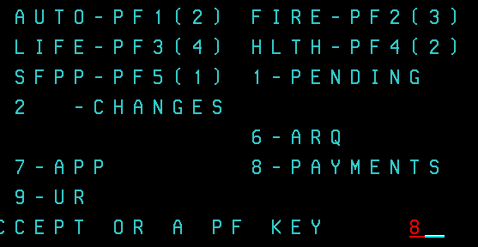

1. On next screen type amount paid, payment type, and if applicable- check #

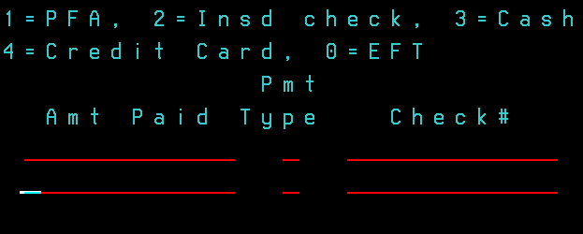

1. On following screen type put your initials in the top blank and the following in the others

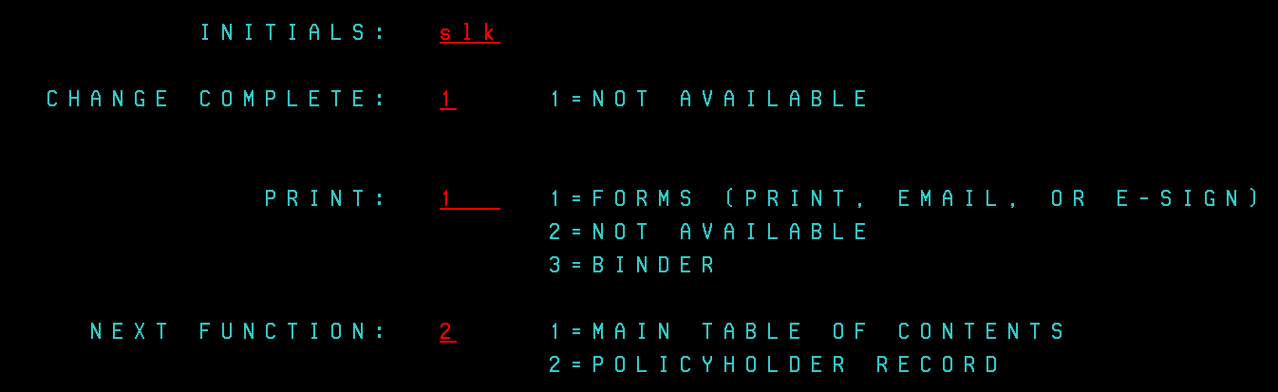

**Updating card holder info:**

1. Go into Billing & SFPP in ECRM
2. Click on account detail

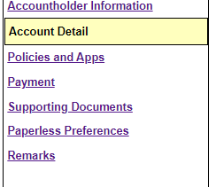

1. Click on Update Account Detail



1. Select New Financial Account

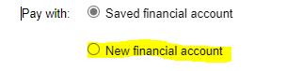

1. Select account type

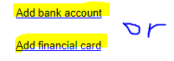

1. Follow prompts to add new bank account or card info in
2. Click submit
3. Email new SFPP auth to be signed under supporting docs

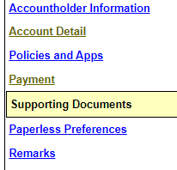

**Moving a policy in SF Billing**

Unlike SFPP, when we cancel a policy, we can not remove it from SF Billing.

Since SF Billing doesn’t remove the policy until the cancellation is processed through our home office, we need to be proactive so they are not being charged for a policy they no longer have. So, when you cancel a policy on SF Billing, please go in and move that cancelled policy to a separate billing account and make notes in ECRM that you did that.



Once you hit “Move a Policy” you will select the policy you want to move and select “Continue”, then you will select “New” for a new account. This will move the policy to a separate billing account that will then be closed out when the policy cancellation has been processed.

**ADA Checks for HO:**

When we write a check for homeowners policies on a claims from the loss.

After we write the check steps:

1 – copy the entire check (front and the upper part of the ADA as well)

2 – Email it directly to the claims: [statefarmfireclaims@statefarm.com](mailto:statefarmfireclaims@statefarm.com)

3 – If approval is needed we need to write that information in the upper part of the ADA check.

* Ex: For Loss of Use approved by Lori Jordan (VAD82D).
* Tye pf Loss: Water Damage to homeowners policy (Policy Number)

4 – Send a copy of the check into the claims directly through the claims portal.

**Being Proactive with Price Increases**

These are to be PHONE CALLS- not texts.

Check to make sure all of the customer’s discounts are still on the policy. If they have been removed by mistake, put in a change in NECHO to add back on and backdate.

Check to see if accident or ticket is now listed, DSS discount recalculated, address change caused rerate.

“Mr. Customer, as you know the current state of inflation has caused the State’s insurance department to reevaluate all of our rates.  With longer rental car periods, price increases on car repairs, and the rising costs of vehicles, every company is taking a slight rate hike and ours is slowly going up to the prices we had PRE-PANDEMIC.  I wanted to let you know this ahead of time and of course, we are always on your side!“

Just making sure there is a REASON & PURPOSE behind our call (taking care of them is the ‘feeling’ portion, while the reason is ‘inflation’ and the purpose is to get ahead of the problem). Mention they still have all of their discounts.

People have a very hard time “breaking up” so if we are proactive and getting ahead of this, gaining agreement, then we should be fine!

Look to see if they are missing discounts, ie DSS.

If there are EXTREME circumstances, review with Adam.

IF increase is over $120- send email below

[Description: state farm logo.](http://www.statefarm.com/)[WWW.INSUREWITHJURS.COM](http://WWW.INSUREWITHJURS.COM)

317-462-6506

Why should you……….

*Insure With Jurs?*

* Our staff has a combined experience of more than 40 years
* Extended Office Hours to meet your needs.
  + Monday-Wednesday-Friday 9:00am-5:30pm
  + Tuesday-Thursday 9:00am-7:00pm
  + Saturday 9:00am-12:00noon (only one in town)
* Instant coverage and binding authority on most properties.
* You can walk into our office and meet with your agent or team members face to face. Offering full service for our customers.
* 24/7 Good Neighbor service available through State Farm when agent’s office is closed.
* Offering over 80 products and services.
  + Renters-Home-Auto-Life-Disability-Commercial-Annuities
* Our team members are your neighbors and involved in your community.
* Rotary, Chamber of Commerce, 4H, Hope House, Kenneth Butler Soup Kitchen, Shirley Turkey Trot, Broken Arrow Outreach, and other local charities.
* State Farm is the #1 insurer of Homes & Autos and has been since

1965. State Farm is 99 years old!

* Find us on FaceBook: Adam Jurs State Farm Insurance

**Adam Jurs State Farm!**

Mr/Mrs. Customer,

Your policy is renewing soon!

First, we wanted to say **thank you for choosing our team**. We are the leading insurance and financial services agency in the entire state of Indiana! We appreciate your confidence in our ability to help you manage risk and recover from the unexpected.

We also wanted to write you with a straightforward message. After substantial declines following the Covid-19 Pandemic, **car insurance rates are going back up** (read to the bottom for some suggestions to reduce premium). It’s not you, and we know that good driving records make it hard to stomach higher premiums. Inflation has had a significant impact on the car shopping, car repair, and healthcare industries. Our office has paid nearly $2,000,000 in auto claims in 2022, over 50% higher than year end 2021. Some of the other reasons we’re seeing increases are:

* **People are driving more** in 2022/2023 than 2021… more than 43 billion miles in the first half of 2022 (that’s more than 1.7M times around the circumference of the earth)
* While there are less injury claims than prior years, the **cost of those claims has increased** more than 40%, eliminating all savings from less injury accidents.
* The **average wait to get into a body shop** has increased to 18.5 days (up from 4.5 days last year)
* The **average time a rental car** is needed has increased to more than 5 weeks (was about 2 weeks prior to the pandemic).
* And perhaps the most unpredictable factor… the **number of claims requiring litigation** has increased at a never before seen rate (we’ll talk about an action you might consider below to protect yourself from our increasingly lawsuit prone society).

While we know none of that information makes it feel better to see higher bills, we hope it provides some context for why rates are going up.

Also, we’d like to offer a few suggestions you might want to consider at this time:

* **Are you driving less than you did before the pandemic?** Email us your estimated annual miles driven and your current odometer and we can make sure your policy is properly classified.
* **Emergency Road Service** has not typically been an expensive part of insurance coverage, but we’re seeing much higher tow costs… if you carry coverage through another organization, you may not want it on your insurance anymore.
* Check out our **Drive Safe and Save** Program. Information is available online at [State Farm.com](https://www.statefarm.com/insurance/auto/discounts/drive-safe-save/) and on [YouTube](https://youtu.be/02kXCpy7IpY). It is ***especially*** valuable for younger drivers and cars that don’t get driven too many miles.
* Consider having us review your home/renters/life insurance coverage… a **multi-line discount** can help save you money on your car insurance.
* Consider your **liability coverage**… as we see more lawsuits, it is important to be prepared should you be at fault in an accident. Carrying higher liability limits (most people should have a liability umbrella) means you get State Farm’s attorneys if you’re in that situation. Here are a few articles on what the policy does for you: [Kiplinger's Article](http://www.kiplinger.com/columns/ask/archive/why-you-need-an-umbrella-policy.html), [Money Magazine Article](https://money.com/what-is-umbrella-insurance/), [CBS News Article](http://www.cbsnews.com/news/why-you-need-umbrella-insurance/), [Fidelity Article](https://www.fidelity.com/viewpoints/wealth-management/do-you-need-umbrella-insurance).
* Schedule time with our office to **review your car coverages**… we’ll look at Rental coverage (The old limits may not be enough, but you may not want this coverage if you have an extra car to use), collision/comprehensive deductibles (many of our customers carry $0 comprehensive deductibles and bumping that up may make sense), and your liability limits.

Once again, ***Thank You*** for trusting the Adam Jurs State Farm team to be your local insurance provider… we couldn’t be more honored to serve you.

**Discounts Falling off**

**MLD/MCD:**

The system will remove the discount if the name and address do not match **exactly** on the policies. The system is not smart enough to match them together if they do not match.

* If this happens, update name and/or address in NECHO to match what is in ECRM and put in to add discount.

**LOYALTY DISCOUNTS:**

The system looks for exposures in the HH who has the oldest tenure. That date is used to decide the loyalty discount- when and how much.

* If a member of the household moves and is removed from that household, the tenure will fall on the next person who has been with SF the longest

**MCD:**

For couples who live together, but not actually married, they have to be NAMED insureds on each other’s vehicles for the discount to be applied.

If there are any questions, you can reach out directly to Rebecca Burns in **auto** underwriting- 678-443-5208

If we see these in BOD- we need to make sure names and addresses match and put a change in necho if not.

**Making Changes to Policies**

On a policy change  (Vehicle/coverage/mortgagee/etc)

Details will still be put in the NOTE attached to the CASE created with the change.

IN ADDITION – A duplicate note should be created on main account page, WITH the date!

Examples:  11/27/23 Vehicle change—traded Subaru for Toyota    or   11/27/23  Mortgagee change due to Refinance with Elements Financial.

If more info is needed then the CASE can be opened and details are there.  This will at least give awareness that a change was made.

**NEVER MAKE CHANGES DIRECTLY IN NECHO!**

How to make changes

* Click on policy in ECRM
* On policy actions click policy change
  + This will create a case
* When in policy type “2” & enter
  + Put in change you need to make
* Put note in case with what you did
  + “updated mortgagee to Huntington”
  + Switched out 16 Ford for 22 Chevy
    - Put VIN & lien holder in note
* Click Submit Request at the top of the case

**Address Changes:**

When changing an address, make sure you follow these steps

1. Change address in ECRM
2. If they have a renters, you need to rewrite to the new address
3. Update the address for ALL policies in ECRM by clicking policy change, creating a case, and updating in Necho+
4. Make sure you notate in ECRM in a note on the main customer page “updated address in ECRM and on all policies, see cases”

On BOD tasks for address change, before marking complete, double check to make sure address was changed in ECRM and the changes were submitted in Necho+

1. If they have not been updated on all policies, put the change in and send an email to the person who updated the address to remember to change address on all policies.- Copy Steph into email.

When the new homeowners or renters policy issues, a lot of the time the address will be the old one. You will need to create a case and submit an address change to update mailing address to same as location.

**Adding New HH Members**

Go into ECRM

1. Click on Household members on left hand side

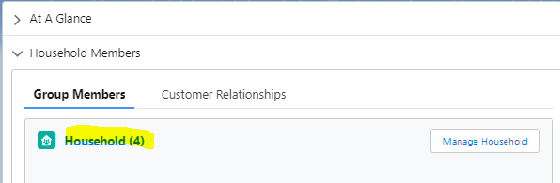

1. In the upper right hand of screen click Manage Household Members

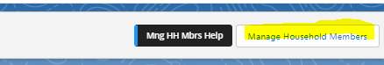

1. Select which option you would like and follow prompts to complete

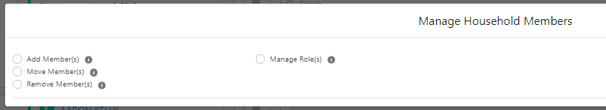

**DEPOSITS:**

* Go into ABS and click Office Admin
* Click Trail/Final Deposits
* Get green envelope in bottom drawer of front desk
* Add up cash and put in cash box
* Add up checks and put in check box
  + Make sure checks are stamped on the back
* Click Compare
* If in balance click Finalize
* Print off deposit sheet and give to Pam
* Go to bank- Star Financial on 9 by Home Depot
* Make deposit and make sure you get a receipt
* Give receipt to Pam once back at office

**History of Altered Money (messing up a payment)**

* Email Adam with customer name and what happened
  + Put wrong check number in, put wrong amount in, etc.
* Weekly report will be printed off
  + You and Adam will have to sign and you will need to write what happened and why the payment was changed

**Drive Safe & Save**

**1ST Notice Setup not Completed**

**Call:**

**Hi ________. This is _______ at State Farm. We are not showing the setup has been completed on your Drive Safe & Save. This needs to be completed by xx/xx/xx to ensure the discount does not fall off, which will cause a balance due. Please let us know if you didn’t receive the beacon or have issues setting it up.**

**Text:**

**Hi ______. Drive Safe & Save has not been setup on your (vehicle). This needs to be completed by xx/xx/xx or the discount will fall off causing a balance due on your bill. Let us know if you need any help with setup.**

**2nd Notice Setup Not Completed**

**Call:**

**Hi _______. Your Drive Safe & Save setup is not complete. The discount will fall off your (vehicle) on xx/xx/xx. Give us a call back asap to verify you received the beacon.**

**Text:**

**Hi _____. Your Drive Safe & Save discount will fall off your (vehicle) xx/xx/xx if setup is not completed. This will be backdated and cause a balance due. Let us know if we can help with the setup. Thanks!**

**Final Notice- Setup Not Completed**

**Call:**

**Hi _____. Your Drive Safe & Save Discount is about to fall off your (vehicle). Setup needs to be completed asap to keep the discount.**

**Text:**

**Hi ______. Your Drive Safe & Save discount is about to fall off your (vehicle). Setup needs to be completed asap or you will receive a balance due bill from the discount being removed.**

**Discount Removed**

**Call:**

**Hi _____. The Drive Safe & Save discount has been removed from your policy due to setup not being completed. You will receive a balance due bill from the discount being backdated. If you would like to add it back on, give us a call at 317-462-6506.**

**Text:**

**Hi _____. The Drive Safe & Save discount has been removed from your (vehicle) as setup was not completed. You will receive a notice for a balance due from the discount falling off and being backdated. If you would like to add Drive Safe & Save again, please let us know.**

**How to tell if setup is complete:**

1. Go into auto policy in ECRM
2. Click View Policy Details



1. Click Discounts and Surcharges on the left hand side
2. Scroll to bottom where it says Drive Safe & Save- Mobile

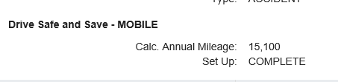

* 1. It will say COMPLETE if setup is done

To Troubleshoot DSS- have the customer call 888-559-1922

For OH-

1. The customer needs to download the Drive Safe & Save app and complete enrollment steps
2. The beacon will be shipped once those steps are completed

**DSS Accident Detection**

What it is Starting Feb. 12, Drive Safe & Save mobile app customers may opt into a free new safety feature called Accident Assistance. When the mobile app and beacon detect a possible auto accident, customers are contacted to ask if they need help. If there’s no response after multiple attempts, the customer’s device location when the accident was detected is sent to local law enforcement for a wellness check. Action requested Consider including the value of Accident Assistance when sharing information about Drive Safe & Save Mobile to customers. Encourage customers to log in as themselves and not share login credentials with other household members or insureds. This ensures the correct customer is called during a detected auto accident. What’s new Customers may ask about the new feature, which will be highlighted with a one-time popup over the dashboard when opening the mobile app. Once rollout is complete (about 10 days), customers will receive an email introducing Accident Assistance benefits. Accident Assistance does not change how agents are notified of claims but will streamline the process by automatically creating claims for an accident scene tow. Zoom in During Accident Assistance enablement, customers will be asked to log in with their own credentials and update their mobile number, if needed. If a customer has login issues: Consider checking for duplicate ECRM profiles or reenter the entire driver’s license number in ECRM (even if the last four digits show correctly). If still unable to resolve customer login issues, the customer or the agent and ™ customer together may contact the Customer Care Center (CCC) Internet Support at 888-559-1922 (customerfacing). CCC specialists may create tasks to agents for after-hour requests, as they are unable to update driver license numbers in ECRM.

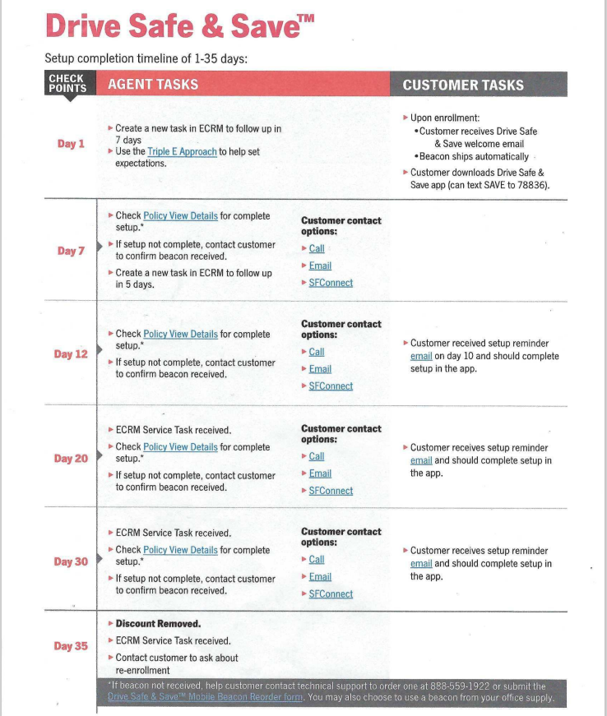

**Odometer Request text**

Good morning! Please login to the Drive Safe & Save App to update your mileage or send us a text back here with your mileage so you don't lose your discounts! Thank you!

**DSS Notes**

1. New beacons are now being sent for vehicle switch outs
2. If too much time elapses from old car to new car DSS set up, the discount is totally re-set and recalculated to “initial discount” and their prior driving score is not carried over. If they had a really good score previously, it could reduce their discount when it starts over.

**Requesting a new beacon**

1. Go into FORMS on Agency Hub Home
2. Search for Drive Safe & Save
3. Verify discount is still on policy
4. Fill out information on form and submit

**NEW CASES—Claim Filed**

**Auto Claim Filed**

* Take a quick look at the facts to see how serious it is.
* Call the insured
* “I saw that you filed a claim—is everyone okay?”
* Is Your vehicle driveable?
  + If not—where was it towed?
* Was a Police Report made?
  + If yes—Who was driving?
  + We need their D/L#
  + File COC for IN on the BMV website <https://secure.in.gov/apps/bmv/olvs/>
    - Form you will need to choose is Certificate of Compliance
    - Fill out the information in form
      * Make sure you put the policy start date and end date correctly, as well as the date proof of coverage was needed- the accident date
* Document Conversation in ECRM including whether PR made and COC was filed.
* Make a task to follow up in 3-5 days
* Do you have any questions for us? Anything you need help with?

**Auto Claim Not Filed- customer calls in**

* Ask what happened
  + Vehicle that was involved in accident
  + Driver
  + If police report was filed get DLN for person driving
    - File COC with BMV
    - Save COC in client file
  + Transfer the customer to claims
    - In Jabber click on 3 dotted button next to red X
    - Click Transfer
    - Type in claims number- 855-259-8568 & hit transfer & hang up
    - ALWAYS GIVE THE CUSTOMER CLAIMS # INCASE THEY GET DISCONNECTED

**Towing**

* We can reimburse up to $100 in office with valid tow receipt. Anything higher needs to be submitted for review and reimbursement\
* ERS phone # 877-627-5757

**Fire Claim Filed**

* Take a quick look at the facts to see how serious it is.
* Call the insured
* “I saw that you filed a claim—is everyone okay?”
* If HO—Can you stay in your house?
* Have you gotten an estimate for repairs?
* Do you know who you want to do the repairs?
* Did Claims schedule an inspection?
* Make a task to follow up in 3-5 days.
* Do you have any questions for us? Anything you need help with?
* If severe loss & they cannot stay in their home, we can issue a check for emergency expenses

**Fire Claim not Filed- Customer calls in IF YOU DON’T KNOW ADAM TAKES CARE OF THEM!**

* Ask the customer what happened
* Let them know to get an estimate BEFORE filing the claim
  + Let them know their deductible
* Let the customer know to call us after they get the estimate
  + If it is claim worthy transfer the customer to claims to get things started

UW Claims Folders:

Under three years-call within 30-45 days. Green check when you’ve gotten ahold and also mark in notes in ECRM.  Otherwise, keep calling daily until you get ahold of them.

Over three years-PRINT ALL.  Anything worth appealing, create notes, otherwise leave blank, but still print.   If appealing, need all policies for the HH.

Ask if we can call them back in a year, and if they need a recommendation.

**Send Email template for Day 1 Below**

**Your Claim Information**

Please disregard this email if you’ve already received this information.

|  |  |  |
| --- | --- | --- |
| Claim Number |  |  |
| Claims Phone Number | (855) 341-8184 |
| Claims Email | [statefarmclaims@statefarm.com](mailto:statefarmclaims@statefarm.com) |
| Contact Name |  |
| Agent’s Office Phone Number | 317-462-6506 |

|  |  |
| --- | --- |
| **Access Your Policies 24/7**  When you log in through [statefarm.com](https://www.statefarm.com/) or the [State Farm Mobile App](https://www.statefarm.com/customer-care/download-mobile-apps/state-farm-mobile-app) you can:   * Track this claim * Easily access your Auto ID Cards * Pay your bills * Go paperless * Manage your accounts   If you need help logging in, our support team can be reached at (888) 559-1922.  To get started, text “Mobile” to [78836](sms:78836&body=mobile) or click the links below |  |

**Important Auto Claims Information**

<https://www.statefarm.com/claims>

**Repair Facility Locator**

<https://www.statefarm.com/claims/claims-help/auto/repair-services>

|  |  |  |  |  |  |  |  |  |  |  |  |  |  |
| --- | --- | --- | --- | --- | --- | --- | --- | --- | --- | --- | --- | --- | --- |
| |  |  |  |  |  |  |  |  |  |  |  |  |  | | --- | --- | --- | --- | --- | --- | --- | --- | --- | --- | --- | --- | --- | | |  |  |  |  |  |  |  |  |  |  |  | | --- | --- | --- | --- | --- | --- | --- | --- | --- | --- | --- | | |  |  |  |  |  |  |  | | --- | --- | --- | --- | --- | --- | --- | |  |  | **Jurs Insurance and Financial Services, Inc.**  **Adam Jurs**, Agent  Bus: [317-462-6506](tel:317-462-6506) 325 E Main Street Greenfield, IN 46140-2307   |  |  | | --- | --- | |  | | |  |  | | |  |  |  | | |  | |
| |  |  | | --- | --- | | |  | | --- | | [Get a Quote](https://pii.im/QRTrack.aspx?UQR=01CDB588-DDF3-4E04-90A4-94D03DAD557A) [Visit Agent’s Page](http://www.insurewithjurs.com/) [My Account](https://oams.statefarm.com/auth/UI/Login?module=default&goto=https%3A%2F%2Fapps.statefarm.com%3A443%2Fcustomer-landing-web%2F) [Maps & Directions](https://www.statefarm.com/agent/US/IN/Greenfield/Adam-Jurs-6T3Y59K9TGE/map?officeAssociateId=2MTR39RRYGF) | | |  | |
| |  |  |  |  |  |  |  | | --- | --- | --- | --- | --- | --- | --- | | |  |  |  |  | | --- | --- | --- | --- | |  |  | **Adam Jurs**, Agent |  | | |  | | --- | |  | | |
|  |
| **Providing Insurance and Financial Services** |
|  |
| |  |  | | --- | --- | |  | **If this communication is securities related, see the** [**additional disclosures**](https://www.statefarm.com/finances/mutual-funds/resources/disclosures)**.** | |
|  |

Day 4 – send email below:



Jurs Insurance and Financial Services

State Farm

Claim Concierge Job Description

Job Descriptions are considered general descriptions and recruiting tools; are not intended to limit the assignment and scope of work.

The role of Claim Concierge is to assist and guide customers through the claim process, making it smooth and easy to understand. Our goal is to deliver the promise made at the time of policy purchase; that we will deliver Good Neighbor Service and make their situation as positive as possible.

This is accomplished by:

* Discussing potential claims with the customer, advising them of their deductible, and assisting with turning in a claim should that be necessary
  + Warm transfers to ILR or in times of long holds/wait times
* Handle claims via Agent Draft Authority when they are eligible
  + See ABS link: [Overview - Agent Draft Authority (statefarm.org)](https://sfnet.opr.statefarm.org/agency/manuals/agent_draft_authority/index.shtml)
  + If eligible, obtain two photos and an estimate for repair or replacement
    - Complete ADA template and email to appropriate team member based on their alpha, or to Julia if larger than TM authority.
    - In email, advise if we are to mail draft, when customer is coming by to pick up, or if we need to deliver
    - Advise body shop to contact you if supplemental draft is needed
    - Once draft is complete, copies and any additional documentation is sent back to Claim Concierge to upload and complete process.
    - Fully document ECRM
* If claim is being handled by SF, call to introduce yourself and your role
  + Explain the next steps and claim process
  + Set expectations for timely contact by claims, scheduling of inspections and having roofer, vendor present at that time as well
  + Send Day 1 email for claim
* Set 1/4/7 day follow-ups in ECRM
  + Day 1- Call Customer and send 1st day email
  + Facilitate positive communication between customer/vendor/claims  
    Most concerns are due to lack of, or poor communication. We can alleviate a great deal of troubles by staying on top of these areas.
  + Advise customers to set up their on-line SF account if they haven’t already, and ***add bank information for upcoming claim payments***. This step will **drastically** improve the time it takes for them to be paid.
  + Day 4- Send Day 4 Email
  + Day 7- Call to verify everything is going smoothy.
    - Close out case
* Receive and upload documentation directly to claim via ECRM (photos, invoices, etc)
  + From customer and vendors
* Escalate any situation that is not being handled properly or in a timely manner. Contact the claim adjuster first, and if no headway is apparent, go to their supervisor and Claim Team Manager next. Advise Julia of any situation that isn’t solved quickly, so she can get involved.
* If the customer is upset about a claim decision, call claims to find out the situation, review photos, estimate, and help customer understand the coverage and contract.
  + If you believe the claims decision is wrong, escalate as described above
* After claim is complete, ask for a 5-star review and follow up with text/email including link for google and Facebook reviews
* Claim Concierge will also work with claimants from time to time. If that process goes well, ask if we can have the opportunity to quote their business and refer to the appropriate team member for follow up.

Every person and role on this team is critically important to our overall success. Having direct contact with customers during the claim process is an amazing opportunity to showcase how we are different, and why they should stay with us for a long time.

Look at each interaction as an opportunity to prove we’re the BEST.

Thank you for what you do!

**CLAIM INFO – Car Rental & Travel Expense**

Rental Reimbursement extends coverage WHILE THE VEHICLE IS NOT DRIVABLE. Insured can be in a rental up to policy maximum *or* when repairs are complete *or* 7 days after Total loss offer—whichever is less.

**EXAMPLES:**

1. **Accident occurs on June 1—Vehicle is drivable** 
   1. Once vehicle goes into shop for repairs policy begins paying for Rental car
   2. When repairs are complete, Rental car must be returned (coverage ceases)
2. **Accident occurs on June 1—Vehicle is not drivable but repairable**
   1. Rental coverage is available immediately
   2. Coverage ends when one of these happens
      1. Repairs are complete
      2. Benefit is exhausted (Example R1 $50/$1200) [sales tax not included in this illustration] If $50/day—coverage runs out at 24 days. If $40/day—coverage runs out at 30 days. If $30day—coverage runs out at 40 days. *IMPORTANT to choose wisely if repairs will last a while.*
3. **Accident occurs on June 1—Vehicle is not drivable and likely Totaled**
   1. Rental coverage is available immediately
   2. Coverage ends when one of these happens
      1. Total Loss offer is made – Rental extends for 7 days.
      2. Benefit is exhausted (Example R1 $50/$1200) [sales tax not included in this illustration] If $50/day—coverage runs out at 24 days. If $40/day—coverage runs out at 30 days. If $30day—coverage runs out at 40 days. *IMPORTANT to choose wisely if repairs will last a while.*

**CAR RENTAL & TRAVEL EXPENSE** also includes “Travel Expense” so if an accident occurs in Florida and the insured chooses to Fly back to Indiana, that expense could be covered by R1 and amount of plane ticket subtracted from benefit. (**EXAMPLE**: $50/$1200 benefit—plane ticket $300; $900 benefit still available for rental car)

**Emergency Road Service Claim payments:**

**SUBMITTING TO CLAIMS FOR PAYMENT:**

1. Scan a copy of the receipt and save in W-drive
2. Go to ABS
   1. Click on **SERVICES** tab (Red)
   2. Then Click on **CLAIMS** tab (gray)
   3. Drop down to LOSS RERPORTING and click on “CLAIMS ASSIGNMENT DISTRIBUTION APPLICATION (previously ADA Claim Submission)”
3. At the top of the page click on **AGENCY** in the red bar
4. Select which Agent Code you will be submitting for and then this will pop up.

1. Click on “Create New Record”
2. Fill in the form (yellow boxes) as requested. As you answer—new boxes will appear.
   1. On “Work Type” be sure to select “Fast Track”
   2. Agent’s Draft is chosen if check was issued in the office.
3. In the Comments box you will type—PAY INSURED or PAY PROVIDER.
   1. We almost always Pay INSURED because they have already paid the Provider
4. Once all the necessary info is entered, you need to attach the receipt
5. Once the receipt is attached you will click SUBMIT
6. It may look like nothing happened; at the top of the page it will say “Claim has been Submitted”
7. Then make a task in ECRM – “5/10 submitted Tow Bill for reimbursement” with follow up one week later to see if it has been paid.
8. Typically payment is disbursed within 4-5 days.

**PAYING THE CLAIM IN OFFICE**

1. Confirm Coverage is in force on the policy.
2. Confirm receipt shows correct vehicle, date, and amount.
3. Payment can be made IN OFFICE up to $120.00 and within 30 days of loss.
4. Complete upper portion of the draft
   1. Vehicle information
   2. Location of loss (where was vehicle picked up or service provided)
   3. Skip the portion about SR21, etc.
   4. Enter Date Reported
   5. “Describe cause of loss…” I usually just put *“Vehicle wouldn’t start, towed to mechanic*” or “*Change of Tire*” (whatever was done—doesn’t have to be detailed.)
   6. Type of loss – ERS
5. Complete the draft with info as requested
6. Be sure to select whether it is Mutual or Fire & Casualty (1-*, 2-* & 3-*)
7. SCAN the check before giving it to the customer.
8. Customer ONLY receives the Green portion, keep the top portion and carbon copy for us.
9. Then you go to ABS to record the payment.
   1. Click on **SERVICES** tab (Red)
   2. Then Click on **CLAIMS** tab (gray)
   3. Drop down to LOSS RERPORTING and click on “CLAIMS ASSIGNMENT DISTRIBUTION APPLICATION (previously ADA Claim Submission)”
10. At the top of the page click on **AGENCY** in the red bar
11. Select which Agent Code you will be submitting for and then this will pop up.

1. Click on “Create New Record”
2. Fill in the form (yellow boxes) as requested. As you answer—new boxes will appear.
   1. On “Work Type” be sure to select “Agent’s Draft”
   2. Fast Track is chosen if Claims will be paying it.
3. Once all the necessary info is entered, you need to attach the receipt & copy of the Draft
4. Once the receipt & draft are attached you will click SUBMIT
5. It may look like nothing happened; at the top of the page it will say “Claim has been Submitted”

**Onboarding**

**Onboarding Processes for Instant Issue (OH) and Gainsco**

**OH- Instant Issue**

* Put a task out for 10 days to follow-up and onboard & put on your calendar
  + Make sure they downloaded the SF app
  + Check if beacon received and DSS setup
  + Check to make sure all forms are signed
    - Selection rejection, SFPP, GSD, SCD
  + Make sure they understand their coverages
  + Pivot
* Create simple in ECRM and mark complete- document in simple that you discussed the above with the customer

**Gainsco**

* Put task out for 1 week & put on your calendar
  + Make sure they received their documents in the mail
  + Make sure anything that needs signed is completed
  + Make sure they understand their coverage
  + Pivot

**Forms needed for new HH**

* Steer Clear
  + Can find in State Farm Forms in Agency Hub
* Selection Rejection
  + Can send electronically through Necho or found in State Farm forms in Agency Hub
* SFPP recurring authorization
  + Send electronically from SFPP account
  + If business account, can’t do electronic auth, have to mail or email form
* Grades for Good Student Discount
* For Antique/Classic
  + Pictures
    - Engine
    - Angled photo of the front and one side
    - Angled photo of the rear and other side
    - Interior
    - Dash
  + Antique valuation form
    - In State Farm forms in Agency Hub

**Onboarding updates 2024**

Commissions will not be paid on new households if onboarding is **not** completed in its entirety. This includes the following:

* Calling new customer to go over issued policies
  + Documenting a simple in ECRM with EVERYTHING talked about
* DSS needs setup- if it falls off, commission will be taken back
* ALL documents need signed
  + Selection Rejection
  + Steer Clear
  + SFPP auto pay
  + Grades received

Tell the customer you will be calling when the policy(s) issue in about 7-10 days, call when autos issue, you do not have to wait for fire policies to issue. Make sure you tell him it is very important that they answer your call and reiterate this again before hanging up. Copy and paste the following into the simple and fill in. If something does not apply, put N/A

SF AND DSS APPS DOWNLOADED:

DSS BEACON RECEIVED:

DSS SETUP COMPLETE:

SELECTION REJECTION:

STEER CLEAR:

GSD:

SFPP AUTH:

GOOGLE REVIEW COMPLETED:

REFERRAL:

PIVOTS:

NOTES: (include anything else you talked about)

**Prior to completing the sale:**

BEFORE you hang up with a new customer tell them you are texting them a link to leave us a Google Review.

So Mr. Scott, I will call you once the policies issues. I ALSO just sent you a text with a link to our Google Page. Could you please take 30 seconds to leave us a review to help me win a contest for December?

**WHILE you are on the phone telling them this, text the link- that way when they hang up they see the text and click the link.**

**Text:**

**Welcome to our State Farm Family! Could you please help us and share your feedback?** [**https://g.page/r/CWny9gHk-KwJEAo/review**](https://g.page/r/CWny9gHk-KwJEAo/review)

Put a note in ECRM- Texted Google Review Request 12/xx/22- and include your initials.

**When quoting:**

MUST document FORM (formally FOR)- document in ECRM in client file, not in the opportunity. Label the subject as FORM xx/xx/xx. Copy and paste the following in the body and fill in:

FAMILY:

OCCUPATION:

RECREATION:

MOTIVATION FOR SWITCHING INSURANCE:

**Email to Adam**

Subject: Sale

Body:

Name of Customer

Source

# of autos & premium

# of fire & premium

Any other policy & premiums

Google review sent

Welcome email sent

Thank you card sent

When onboarding is scheduled for

**Life Onboarding:**

Email Person who sold the policy and copy in Amy

Subject- Life Packet Arrived for ______

Body:

Please onboard and let me know when to send out life packet

**Make note in ECRM:**

Life packet came in XX/XX/XX- emailed ______ & Amy to onboard

**When you mail life packet note in ECRM:**

Mailed life packet XX/XX/XX

**Amy is the only one to follow up on documents needing to be signed.**

**Onboarding CALL Script**

Hey _____! It’s __________ with State Farm. How are you?

Great! So I have good news, your X policy has issued as we quoted. Have you received the documents for everything in the mail?

(client response)

Great, have you download the two apps, the Drive safe for the discount and the state farm app as well?

(client response)

Beautiful, do you have the beacons for the DSS discount as well? – Yes okay great, have you set them up yet just a reminder it MUST be set up to continue that discount.

No – okay, let me see where they might be (if they are not local)

No – okay, when you come to the office we have spares and we can give you some while you are here and help you set it up.

Additional Discounts (if needed)

I have not gotten back the form for the Steer/Good/Sel-Rej form.

“what’s most important to you when it comes to your insurance agent?” I think this will help us know WHO to put them in front of. What do you think?

Lastly, looking at your calendar what is a good time in the next week to sit with (Pam/Adam) like we talked about to build the relationship, get to know the office, and see who we are.

**Appointment Setting Script:**

*Hey (insert name). This is ______ over at State Farm. How are you?*

*We just want to call to say Thank You for your business and loyalty. Every other year, we offer an in-person discount review (If far away, offer phone/virtual). We would like to schedule a short casual visit with Adam (or Pam) at our office. The purpose of the visit is just to make sure you’re getting all of the new discounts we have, as well as an overview of any gaps that we may have found due to Covid. The conversation should take about 30-45 minutes.*

*Would afternoons or mornings work better for you? (Wait for their answer)*

*We typically schedule afternoon appointments and possibly into the evening on Tuesdays and Thursdays. We are setting the appointments two-three weeks out right now. Is there a certain or time that works best for you, I have this _____ at _____ or ____ at _____? (Let them tell you what time and day works best).*

*Okay, perfect! I have you down for _____ on _(week) day_, the _(date)_ of _(month). You will be speaking with __________.*

*Are you familiar where the office is located? (We are just 3 blocks east of the courthouse. The old Shelby Oil building. Parking is off Swope and Main, but you can’t miss the State Farm billboard and the large white building with red shutters.)*

*I am also going to send you a calendar invitation to your email, let me confirm your email is* [*____@_______.com*](mailto:____@_______.com)*.*

*Finally, Adam(or Pam) loves to review any financial policies outside or at work if you need any help, please bring those with you. (I.E. Old 401ks, health insurance at work, life at work..)*

*Do you have any questions for me?*

*Thank you for accepting my call, ___ (customer name) __. We look forward to meeting with you (restate the appointment info).*

**BOD**

**Cases**

1. Put notes in the case on what you did
   1. Cancelled policy & the reason it was cancelled- sold, ROC, state to state, etc
   2. Replaced vehicle X with vehicle Y
   3. Attached doc- what was attached
   4. Changed mortgagee
   5. Added vehicle & include vehicle info
   6. Anything else that you may have done
2. Make sure you hit **Request Submitted** at the top of the case once you finish putting the change in
3. If you accidentally created the case/change, there is a button at the top that says **“Created in Error**”- make sure you hit that and delete the case

It would be helpful to put the VIN & Lien holder info or mortgagee info in the notes for the case so we can make sure it is correct when the policy issues.

**SFPP Folder**

1. Email for electronic authorization in SFPP account
   1. Go into SFPP and supporting document to send email
2. Call to let them know we sent email and need electronic auth
   1. “Hi ______. We are needing authorization for your auto pay on your monthly account. I sent an email over to [________@___.com](mailto:________@___.com) for an electronic authorization. If you do not receive it in your inbox, check your spam folder as it can go there sometimes.”
3. Text if you do not talk to them
   1. “Hi _____. I sent an email to [______@___.com](mailto:______@___.com) for an electronic authorization on your auto pay. Please complete the authorization asap. It can go to your spam folder if you do not receive it in your inbox. Let us know if you have any questions.”
4. Document in ECRM
5. Mark email complete

**Paper Apps Folder**

1. Click on “My Application Dashboard” link in the email.
   1. Check status of app
      1. Will either be in Submitted or Issued
2. If issued go into ECRM and make sure the policy is showing issued
   1. Verify policy number in dashboard and ECRM match
   2. Mark email complete in Paper App Folder
3. If it is not issued mark the email with a flag to follow up

**Policy Issued BOD**

1. Pull up opportunity in ECRM and open quote.
2. Pull up policy in Necho
3. Confirm the policy issued at the amount quoted.
   1. If so, email person who wrote the policy and let know policy issued as quoted
      1. Jane Doe- auto issued as quoted
   2. If it issued differently email the person who wrote the policy & copy in Adam
      1. Put notes if you see why the policy issued differently.
         1. Jane Doe- auto issued at $500, quoted at $400. (Issued without MLD, rated at 3*, etc)
         2. John Doe- HO issued at $1200, quoted at $1400
4. Close out task

**Late Pay Offer- THESE GET EMAILED TO AMY AND ASSIGNED TO HER**

**Address Change BOD**

1. Pull up customer in ECRM & Necho
2. Verify address in task matches the address in ECRM & Necho
   1. If necho address isn’t the same look to see if change was put in to update
   2. If not, put in necho change on all policies with new address.
   3. If changing a mailing address on a HO, you MUST include remarks “changing mailing address to same as location”- system will not match the two
   4. Address change on renters must include a renter’s rewrite
3. Mark task complete

**Total Loss Claim BOD**

1. Call customer to let them know their vehicle has been deemed a total loss- claims may have called already- if claims has not called, give them claims team number to follow up on
2. If they are in a rental, you must keep the coverage active on the totaled vehicle
   1. The coverage from the vehicle transfers to the rental in case there is an accident while they are in the rented vehicle
3. If they are not in a rental, and NOT replacing soon, put in a Necho change to do a total suspension on the vehicle
   1. Put suspension effective the day after the loss
4. If they are replacing soon, leave coverage in effect and let them know to call us once they have the replacement
5. Let customer know to call us when they get a new vehicle so we can add the vehicle and reinstate the coverage.

**Financial Info Not Updated**

1. Call customer to let know we need to update their payment info
   1. Hi ______. This is _______ at State Farm. The card we have on file for your monthly billing is set to expire. Please give us a call to update your account.
2. Send text if they do not answer
   1. Hi _______. Please give our office as call back asap regarding your account. Thanks!
3. Put note in task and close

**Unassinged Driver in HH**

1. Call customer to verify if person listed in task is a driver in the HH and if so what vehicle they need to be assigned to
   1. Hi ______. This is _____ at State Farm. We are showing _______ is in your household, but not assigned to a vehicle. What vehicle do they drive?
      1. Put change in necho to update driver assignment
2. If they do not answer, leave vm and send text to call back
   1. HI ______. Please give our office a call back asap regarding your account. Thanks!
3. Put notes in task and mark complete

**Renters Rewrite**

1. Verify address in ECRM and necho have been updated to the new address in the renter’s policy
   1. If not put changes in necho/ECRM
2. Put notes in task and mark complete

**GIO –**

Put task in Adam’s name and send him and email

Subject: GIO for ________

Body: GIO available- needs completed prior to XX/XX/XX

**UW Cancel/Drop—**

ALWAYS Refer these to Adam; he will review the situation to see if it can be appealed or if Cancellation or Non-Renewal is inevitable.

DO NOT call the insured

**Policy Reinstated with TOOF/Continuous Coverage**

1. Mark task complete

**Review Estimated Replacement Cost**

**Call to set a 30 minute phone appointment with Pam to go over their ERC and HO policy:**

“Your homeowners is coming up for renewal and with the updated replacement costs and inflation we were wanting to go over with you real quick. We would like to schedule a quick phone call with Pam.”

**IF MOA- appt needs to be set with Adam for 1 hour.**

“Your homeowners is coming up for renewal and with the updated replacement costs and inflation we were wanting to go over with you real quick. We would like to schedule an in-office appointment with Adam. What days and times work best?”

**Increases- PAM HANDLES**

1. Pull up policy in Necho to see what changed to cause increase
   1. GRG/DRG
   2. Discount fell off
   3. Driving record (easier to see in policy view in ECRM)
2. If increase is less than $10/month mark task complete
3. If increase is more than $10/month call customer
   1. Mr. Customer, as you know the current state of inflation has caused the State’s insurance department to reevaluate all of our rates.  With longer rental car periods, price increases on car repairs, and the rising costs of vehicles, every company is taking a slight rate hike and ours is slowly going up to the prices we had PRE-PANDEMIC.  I wanted to let you know this ahead of time and of course, we are always on your side!
   2. Leave a vm with info if they do not answer
4. Put notes in task and mark complete
5. If discount was removed in error, put in a Necho change through ECRM to make a case to add discount back on, and put qualifying policy number in remarks
   1. “please add MLD back on- qualifying policy xx-xxx-xxxx”

**Decreases**

1. Call customer to let them know premium decreased
   1. “HI ______! I wanted to share some great news that the premium on your policy has decreased by $xx for 6 months!”
   2. Leave a voicemail if they do not answer
2. Pivot since they are saving money
   1. Life, health, better coverage, etc
3. Put notes in task and mark complete

**Policy Center BOD**

1. Pull up customer in ECRM and see who wrote the policy
2. Send an email to person who wrote policy and copy Adam in
   1. Subject- BOD Policy Center (Customer Name)
   2. Body- Policy center BOD for supporting docs, approval request, denial, etc
3. Put task in the person who wrote the policy name

**SFPP Late Pays:**

**Day 1:**

**Call:**

Hi _________, this is ______ at Adam Jurs State Farm. Your payment of $____ past due. You can make your payment online or give us a call at 317-462-6506 to make your payment over the phone.

**If they Answer:**

Hi ________, this is ______ at State Farm. We show your account is past due in the amount of $______. Would you like to make that payment with a card or bank account today?

**Text:**

Hi ______. Your payment of $____ is past due on your account. To pay, please click here: http://st8.fm/sfpay or call me at (317) 462-6506.

**Email:**

Send email template (make sure to customize)

**Make notes in ECRM:**

* **Called, text, emailed XX/XX/XX**
* **Push task out to 5 days before cancellation**

**Day 2 (5 days before cancellation)**

**Call:**

Hi ________, this is _______ at Adam Jurs State Farm. Your policy is set to cancel on XX/XX/XX if we do not receive payment of $______. Please call us today to make a payment. 317-462-6506. You can also pay online or through the State Farm App.

**Text:**

Hi ______. We have not received your payment on your monthly account in the amount of $_____. Your policies will lapse on XX/XX/XX if payment is not received. Please call us TODAY 317-462-6506 or you can pay online at http://st8.fm/sfpay.

**Email:**

Send template and customize

**ECRM:**

* **Makes notes and close out task**

**For Life Policies email Amy if you do not get ahold of them and get payment.**

* Subject line
  + Customer name- life not paid
* Body of Email
  + Attempted to contact Customer to pay on life. Did not get ahold of them. Sent email, left vm, sent text. (or whatever you did). Please try and reach out to customer to get payment.

**SFPP Auto Pay Declined- BOD**

**Day 1:**

**Call- if they answer**

Hi _______, this is ____ at Adam Jurs State Farm. Your payment of $____ was returned. Would you like to make your payment via credit card or electronic funds transfer?

**Voicemail**

Hi _______, this is ______ at Adam Jurs State Farm. Your payment of $____ was returned. Please give us a call today to make a payment. 317-462-6506.

**Text:**

Hi ________. Your payment of $____ was returned. To pay, please click here: http://st8.fm/sfpay or call me at (317) 462-6506.

**Email:**

Send email template for draft declined

**Update subject line on task in ECRM**

1. Call/txt XX/XX/XX
2. Push task out 10 days after first contact

**Day 2:**

**Call- if they answer**

Hi _______, this is ____ at Adam Jurs State Farm. We have still not received your payment for $_______. Would you like to make your payment via credit card or electronic funds transfer?

**Voicemail**

Hi _______, this is ______ at Adam Jurs State Farm. We have still not received your payment of $_______. Payment is needed by XX/XX/XX or the policies will lapse. Please give us a call today to make a payment. 317-462-6506.

**Text:**

Hi ________. Your payment of $____ has not been paid, and payment is needed by XX/XX/XX or the policies will lapse. To pay, please click here: http://st8.fm/sfpay or call me at (317) 462-6506.

**Email:**

Send email template for draft declined

**Document ECRM:**

* Call/vm/txt/email XX/XX/XX
* Close out task

**SF Billing Autopay Draft Declined- BOD**

**Day 1:**

**Call- if they answer**

Hi _______, this is ____ at Adam Jurs State Farm. Your payment of $____ was returned. You have been assessed a $20 returned payment fee that will show up on your next bill. Would you like to make your payment via credit card or electronic funds transfer?

**Voicemail**

Hi _______, this is ______ at Adam Jurs State Farm. Your payment of $____ was returned and a $20 returned payment fee has been added to your account. Please give us a call today to make a payment. 317-462-6506.

**Text:**

Hi ________. Your payment of $____ was returned. You have been assessed a $20 returned payment fee. To pay, please click here: http://st8.fm/sfpay or call me at (317) 462-6506.

**Email:**

Send email template for draft declined

**Update subject line on task in ECRM**

1. Call/txt XX/XX/XX
2. Push task out 10 days after first contact

**Day 2:**

**Call- if they answer**

Hi _______, this is ____ at Adam Jurs State Farm. We have still not received your payment for $_______. Would you like to make your payment via credit card or electronic funds transfer?

**Voicemail**

Hi _______, this is ______ at Adam Jurs State Farm. We have still not received your payment of $_______. Payment is needed by XX/XX/XX or the policies will lapse. Please give us a call today to make a payment. 317-462-6506.

**Text:**

Hi ________. Your payment of $____ has not been paid, and payment is needed by XX/XX/XX or the policies will lapse. To pay, please click here: http://st8.fm/sfpay or call me at (317) 462-6506.

**Email:**

Send email template for draft declined

**Document ECRM:**

* Call/vm/txt/email XX/XX/XX
* Close out task

**SF Billing Late Pay:**

**Day 1:**

**Call:**

Hi _________, this is ______ at Adam Jurs State Farm. Your payment of $____ past due. You can make your payment online or give us a call at 317-462-6506 to make your payment over the phone. You will be assessed a $10 late fee on XX/XX/XX if payment is not made before then.

**If they Answer:**

Hi ________, this is ______ at State Farm. We show your account is past due in the amount of $______. Would you like to make that payment with a card or bank account today?

**Text:**

Hi ______. Your payment of $____ is past due on your account. You will be assessed a $10 late fee on XX/XX/XX if payment is not made before then. To pay, please click here: http://st8.fm/sfpay or call me at (317) 462-6506.

**Email:**

Send email template (make sure to customize)

**Make notes in ECRM:**

* **Called, text, emailed XX/XX/XX**
* **Push task out to 5 days before cancellation**

**Day 2 (5 days before cancellation)**

**Call:**

Hi ________, this is _______ at Adam Jurs State Farm. Your policy is set to cancel on XX/XX/XX if we do not receive payment of $______. Please call us today to make a payment. 317-462-6506. You can also pay online or through the State Farm App.

**Text:**

Hi ______. We have not received your payment on your monthly account in the amount of $_____. Your policies will lapse on XX/XX/XX if payment is not received. Please call us TODAY 317-462-6506 or you can pay online at http://st8.fm/sfpay.

**Email:**

Send template and customize

**ECRM:**

* **Makes notes and close out task**

**BOD cancellations- billed through division**

**BOD Warning**

**Call:**

Hey _____. This is ______ at State Farm. I just wanted to let you know your payment of $______ on your (policy) was due on XX/XX/XX. Please call our office at 317-462-6506 to make your payment.

**Text:**

Hi ______, Your payment of $____ was due on XX/XX/XX. To pay, please click here: http://st8.fm/sfpay or call me at (317) 462-6506.

**Email:**

Send Payment Past Due Email

1. Put notes in task and close out

**BOD Cancellation Notice**

**Call:**

Hi _______. This is _______ at State Farm. Your payment on your (policy) was due on XX/XX/XX. Your policy will cancel if payment is not received by XX/XX/XX. Please call our office to make a payment.

**Text:**

Hey _____. We have not received your payment of $____ on your (policy). Please pay by XX/XX/XX to ensure your coverage does not lapse. To pay, please click here: http://st8.fm/sfpay or call me at (317) 462-6506.

**Email:**

Send Payment Past Due Email

1. Put notes in task and push out 5 days

**BOD Cancellation**

**Call:**

**Auto:**

Hi ______. Your coverage on your (policy) has lapsed due to non-payment. You are currently driving without insurance. Please call our office to make a payment of $_____ to reinstate your coverage.

**Renters/HO:**

Hi ______. Your coverage on your (policy) has lapsed due to non-payment, and you do not have coverage. Please call our office to make a payment of $_____ to reinstate your coverage.

**Text:**

**Auto:**

Hi _____. Your coverage on your (policy) has lapsed on your (policy) due to non-payment. You are currently driving without insurance. Please call our office at 317-462-6506 to make a payment and reinstate your coverage.

**Renters/HO:**

Hi ______. Your coverage on your (policy) has lapsed due to non-payment, and you do not have coverage. Please call our office to make a payment of $_____ to reinstate your coverage.

**Policies Cancelled:**

**Call and VM:**

Hello _______. This is ________ at Adam Jurs State Farm. You payment was not received on your account and your policies have lapsed. Please give us a call today to make your payment to reinstate your policies.

**Text:**

Hi _______. We did not receive your payment on your account and your policies have lapsed. Please give us a call TODAY to make your payment and reinstate your policies. 317-462-6506

**ECRM note on task:**

* Called/vm/txt XX/XX/XX
* Close out task

**SFPP autopay not signed:**

**These are in the SFPP folder**

**Call/Vm:**

Hi ______, this is _________ at Adam Jurs State Farm. We have not received authorization for your automatic payments on your billing account. We need to have this completed by XX/XX/XX or your billing account will revert back to manual monthly payments. I have resent the form to (their email). Please call us at 317-462-6506 if you did not receive it.

**Text:**

Hi ______. We have not received your electronic authorization for your automatic payments on your billing account. We need this completed by XX/XX/XX or your billing account will revert back to manual payment. I have sent another form for electronic authorization to (email address). Please let us know once completed. Thanks!

**SF Billing autopay auth not received:**

**These show up in BOD as consent about to expire**

**Call/vm:**

Hi _____, this is ______ at Adam Jurs State Farm. Your consent for your automatic payments is about to expire. We texted the electronic authorization to (phone number). Please let us know if you need us to resend. Without consent the billing account will revert back to manual monthly payments.

**Text:**

Hi _______. We have not received your consent for automatic payments on your account. We sent a (text/email) to ________, but it is about to expire. Please let us know if you need us to resend or when it is complete. Thanks!

**Financial Account Information Not Updated:**

**This means the card on file for auto pay is set to expire soon and we need an updated card**

Call:

Hi _______, this is ________ at Aam Jurs State Farm. The card we have on file for your automatic payments is set to expire at the end of the month. We are needing updated card info. Have you received your new card yet?

Vm:

Hi ______, this is _____ at Adam Jurs State Farm. Your payment information needs updated for your auto pay. Please call us back today to update your card. 317-462-6506

Text:

Hi ______! We are needing to update your card on file for your automatic payments. Please give us a call back today to update. Thanks! 317-462-6506

UW Claims Folders:

Under three years-call within 30-45 days. Green check when you’ve gotten ahold and also mark in notes in ECRM.  Otherwise, keep calling daily until you get ahold of them.

Over three years-PRINT ALL.  Anything worth appealing, create notes, otherwise leave blank, but still print.   If appealing, need all policies for the HH.

Ask if we can call them back in a year, and if they need a recommendation.

**Birthday Calls:**

Hi _______! This is ______ at Adam Jurs State Farm. We wanted to wish you a Happy Birthday on behalf of everyone here in our office. Also, check your driver’s license to make sure it isn’t expired. We hope you have a wonderful birthday!

**Steer Clear Form:**

Go to Agency Hub Home and click on forms

Go to State Farm Forms

Type in Steer Clear and you will choose the first option

Fill in the form and either email as PDF or mail out.

1. Need policy holder name
2. Qualifying driver name
3. Policy number
4. Agent Name and Agent code- Adam Jurs 14-34A8

Selection Rejection:

1. Go into Necho and select vehicle
2. Hit 2 for change
3. Put in effective date (today’s date)
4. On next screen you are going to go to “are documents to be sent to the regional office- put a Y

1. Hit enter
2. #3 for selection rejection
3. Type your initials
   1. 1 for telephone retrieve
   2. 1 for forms
   3. 2 policy holder record
4. On next screen put a Y next to Uninsured/Underinsured Selection/Rejection Form
5. Go to bottom to sign remotely, click on remote sign, and send email
6. There is a chance you can not send remotely, if so email as PDF- button at top

Send text:

Hi _______. We need a form singed for your auto policy that has been emailed over to you. Please let us know once complete or if you did not receive. Thanks

Call:

Hi _____. We are needing a form signed for your auto policy. I emailed one over to you for a signature. If you do not receive it, we can try emailing again or send in the mail. Thanks!

**Win Back – Sales Process**

**Generate your Defector prospect list in Agent Analytics**

* Go into Agent Analytics (ABS > Marketing > Select “Agent Analytics” under Tools)
* Change radio button to “Defectors”
* Change view from “Line Chart” to “Bar Chart” or to get all 3 years at once, type an asterick * in the “Find Customer” Search bar

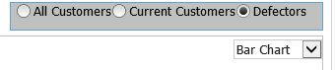

* Select the Bar Chart for the Year & Month (go in chronological order, Oldest Year/Month to Newest)

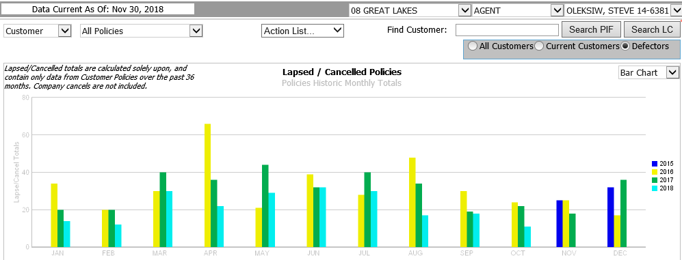

Click on the OLDEST Year and Month, the below listing will be generated

* The below Defector listing will be created for the Year & Month selected

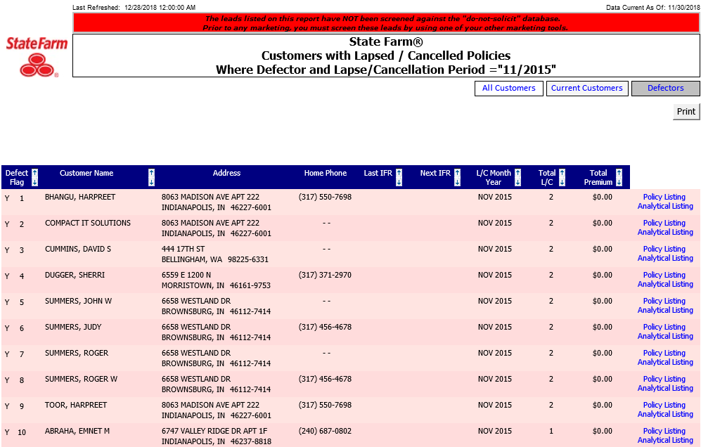

* Click on the “Total L/C” column to sort the LARGEST # of L/C policies at the top
* This helps you to prioritize calling the HHs with the most potential policies first!
* At the bottom of the page, click on “Household List” under “Export to List Manager” (see below). This will export the list to ECRM > List Manager.



* You will get the below confirmation once complete

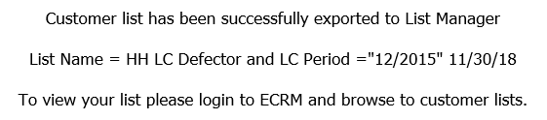

* Keep up the above prospect listing from Agent Analytics OPEN on your screen!
  + Click on the “Policy Listing” link for the prospect in question, which will show you the products and coverages for ALL products they had with us before they defected (see below)
  + You will need this to know what they had with us in the past, coverage limits and also to be able to COPY this information into your ECRM Opportunity Note so you have it for future reference.

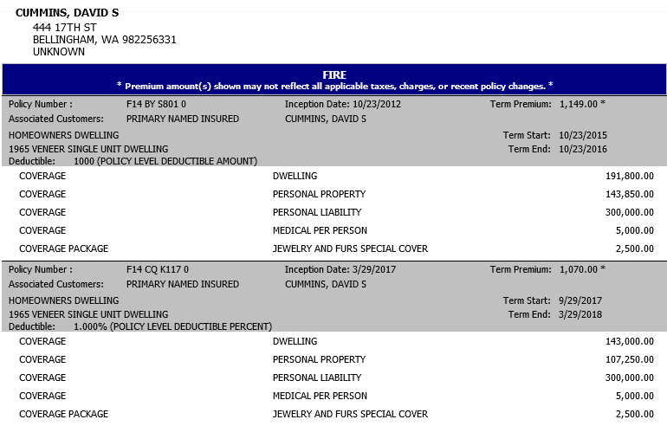

**Find Your List in ECRM and Create a Campaign**

* Open up ECRM
* Go to ECRM > Campaigns > List Manager
* Select View By “Agent Created”

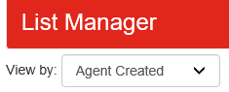

* Find the List that was exported from Agent Analytics
* The below example below was from Nov 2015 “11/2015”



* Click on the # of leads in the “Lead Count” column to access the list
* Click on “Print/Export” on the top right of the page, that will bring you to the following screen

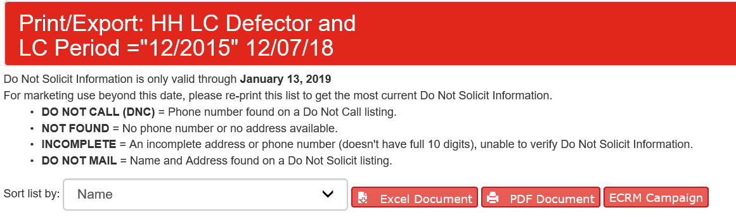

* Click on “ECRM Campaign”…that will initiate the creation of a ECRM Campaign and you will see the following screen once complete. **IMPORTANT: You MUST complete this step of exporting the list to an ECRM Campaign as this list will NOT BE SAVED IN LIST MANAGER!**

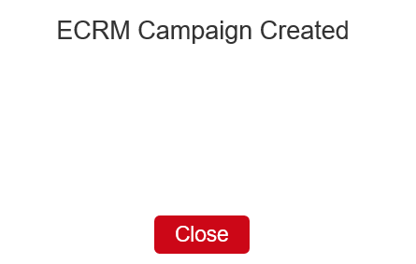

**Finding and Working from the Campaign**

* To access this list, go to ECRM > Campaigns > Prospect Campaigns to find your list
* Access the Campaign
* Click on the first Prospect Name, it will take you to the prospects ECRM Account Page

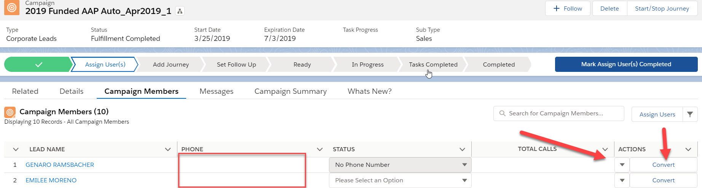

* Look at the At a Glance on the Account Page under “Marketing Call Preference”. NOTE: If it reads “DO NOT CALL FOR MARKETING”, you can NOT call them unless written consent was obtained and documented in ECRM for this calling period
  + If this is the case, please go back to the list in ECRM, click the black arrow under actions and remove from list

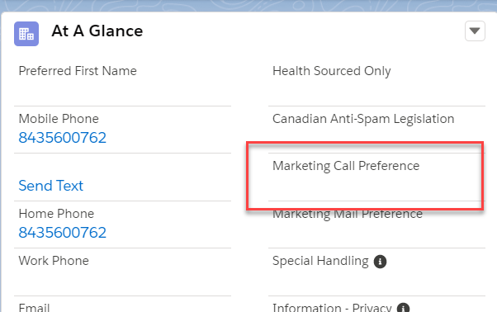

**Research the prospect to prepare for the call**

Remember, keep your Agent Analytics report up (on one of your dual monitors) so you can click on the “Policy Listing” link for details about what policies they had with us, the coverages and termination dates.



Keep your ECRM listing up on your other dual monitor

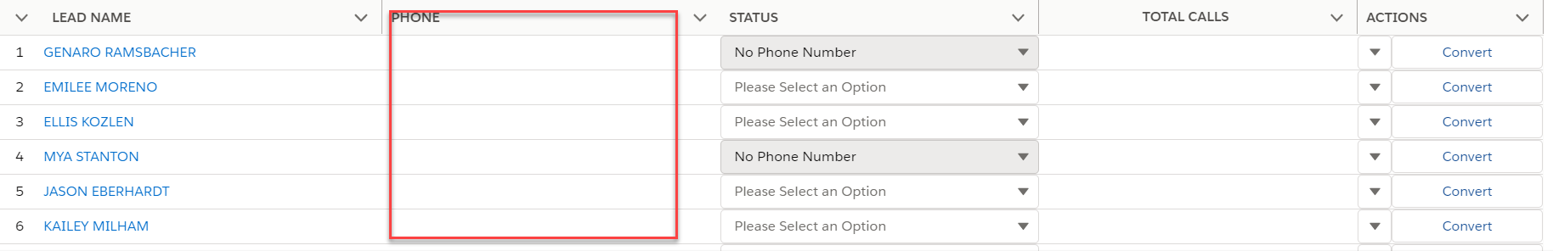

* Click on the prospect name…again, this will take you to their ECRM Account page
  + Note that their ECRM Account Page may NOT have a phone number listed, however you may see a phone number in the Agent Analytics report.
  + ACTION: If this is the case, please add the phone number from the Agent Analytics report to their ECRM Account Page as a **mobile number**
* Once you know what policies they had with us, the coverages and termination dates…
  + **You are ready to start calling**. Note: do not call anyone on the do not call list UNLESS WRITTEN CONSENT TO CALL IS VERIFIED IN ECRM

**Contact Strategy Begins:**

**Outcome Possibilities:**

1. **Contact established**
2. **No contact made**
   1. **Voicemail left**
   2. **Email sent**
   3. **Text sent**

**Contact Established:**

* + *I see you used to be with State Farm. I'd like to talk with you about why you left if you have a few minutes. Could you walk me through your previous experience?  
      
    This is <INSERT YOUR NAME> from your State Farm agent, <INSERT AGENT NAME> office. We’ve had some recent rate adjustments and wanted to reach out and invite you back to our office. Tell me what do you like about your current company?”.  
      
    This is <INSERT NAME> from State Farm agent, <INSERT AGENT NAME> office. We recently sent you some mail regarding your <INSERT PRODUCT DETAIL, i.e. 2012 Toyota Camry, etc.>. Did you receive that mailing?  
      
    We would like to set up time for you to come in to review your coverage needs.*
  + Create an Opportunity in ECRM and set the Stage to “CONTACT ESTABLISHED” or as otherwise appropriate if they agree to a conversation or allow you to quote them
  + **IMPORTANT:** Please copy the Agent Analytics policy listing into your 1st Opportunity Note so you know for future reference what policies they had with us and at what coverage limits.
  + Collect the required information to generate the quotes and use the ECRM Opportunity Note & Follow-up sections as appropriate.

**Voicemail Options**:

Option 1: Minimal Info.

* + *“Hello, this is ______________ at Adam Jurst State Farm office here Greenfield, IN. This is a courtesy call…it’s not URGENT, but it is IMPORTANT…please give us a call back at your earliest convenience at 317-462-6506. Thanks!*

Option 2: More Info.

* + *“Hello, this is ______________ at Adam Jurs State Farm office here in Greenield. This is a courtesy call…you had your ____________ (car/home) insurance with us back in _______ (year) and we want to let you know that we have had several rate reductions that has been helping a lot of past customers save money by returning to State Farm. We have most of the information on your ___________ (Car make & model(s)), so it will be easy to give you a quote. Please give us a call at 317-462-6506 and ask for _______ so we can see if we can save you money too. Thanks!”*

**Email Suggestion:**

Subject Line:

* + “Your ­­­­Year, Make, Model” Example: “Your 2015 Ford Focus”
  + E-mail Body:
    - “Hello, this is ______________ at Adam Jurs State Farm office here in Greenfield. Per my v-mail today, this is a courtesy contact. You had your ____________ (car/home) insurance with us back in _______ (year) and we want to let you know that we have had several rate reductions that has been helping a lot of past customers save money by returning to State Farm. We have most of the information on your ___________ (Car make & model(s)), so it will be easy to give you a quote. Please give us a call at 317-612-1640 and ask for _______ so we can see if we can save you money too. Thank you and make it a great day.”

**Text**

“Hi _____! We wanted to let you know that we have had several rate reductions that have been helping a lot of past customers save money by returning to State Farm. I would love to talk to you more!”

**No Contact Made:**

* Option 1: create a follow up task in. **IMPORTANT:** Please copy the Agent Analytics policy listing into your 1st Opportunity Note so you know for future reference what policies they had with us and at what coverage limits
* Option 2: leave in the Campaign to be followed up on

**Follow Up Processes**

**Example**

Day 1: Call/voicemail

Day 3: Text (if have phone and they are not on the DO NOT SOLICIT list)

Day 5: Call/Voicemaill **AND** E-mail

Day 10: Text if prospect has not reached out yet

Day 13: Call

Day 18: Call

Day 21: Remove from Campaign (or set follow up Sales task on Account page for future date)

* + Option 1: create a follow up task in. **IMPORTANT:** Please copy the Agent Analytics policy listing into your 1st Opportunity Note so you know for future reference what policies they had with us and at what coverage limits
  + Option 2: leave in the Campaign to be followed up on
  + Option 3: An Opportunity was created at some time during your Winback process. If no response from customer, change the stage to “Not Now Follow Up”
    - Create Task to follow up



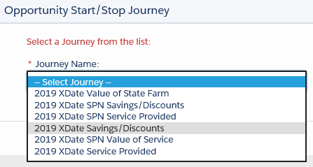

Select the “2021 XDate Savings/Discounts” Journey



* + Option 4: If the prospect is someone we do not want back, they told us they do not want to come back and asked that we do NOT call them anymore, or they are not marketable…
    - On the Prospect Account Page, create a new Note, set Alert as a category, document the reason why we should NOT reach out to them anymore and check the Alert box (see screen shot below)
    - The Alert will show at the top of the Account page. The next time someone is reviewing the list/Account, they will know right away if it is an Ex-Customer we already looked at and will not need to spend the time researching the Account History

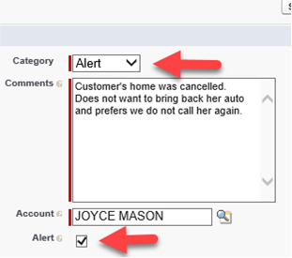

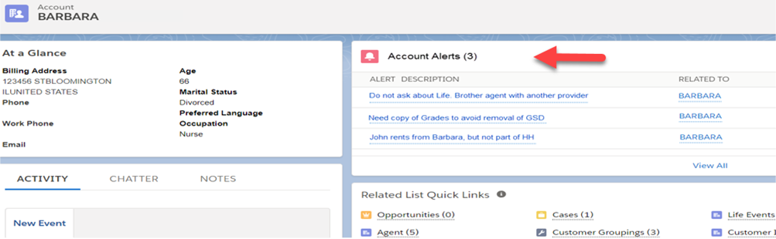

**Other Examples:**

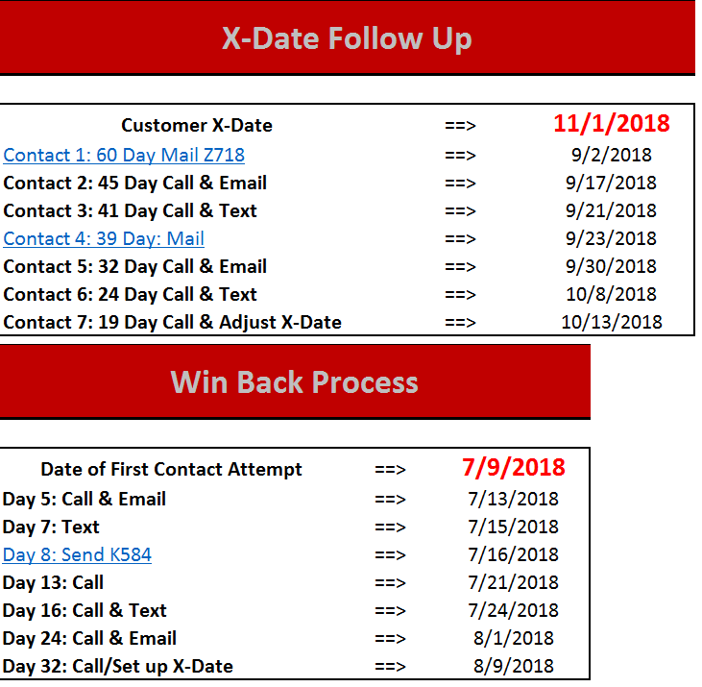

**Multi-Lines**

|  |  |
| --- | --- |
| **Multi-Line Discount Chart** | |
| **Product** | **Discount %** |
| Condo | 15 |
| Condo & Plup | 20 |
| Homeowners | 15 |
| Homeowners & Plup | 20 |
| Farm/Ranch | 15 |
| Farm/Ranch & Plup | 20 |
| Renters | 2 |
| Renters & Plup | 7 |
| Manf Home | 5 |
| Manf Home & plup | 10 |
| Health | 5 |
| Lie < $125,000 | 5 |
| Life >= $125,000 | 5 |

**Multi-line script**

Hey ___ it’s _______ over at Adam Jurs State Farm. I have a quick question about your policy. Give me a call back when you have a few minutes at 317-462-6506. Thanks!

I noticed that you are missing out on a huge discount because you don’t have a renter’s or HO with us. Who are you currently insured with?

*I totally understand however you could save $____ a month on your autos.*

Step 1:

Click on the arrow next to home and go to “tasks”

Step 2:

Click on the highlighted Icon and hit “new”

’

Step3:

Create individual filters for each team member- you will need their aliases.

Sales:

Service:

Step 4:

Save each one and label as the person’s name

* Sales ex: Amy Sales Tasks
* Service ex: Pam Service Tasks

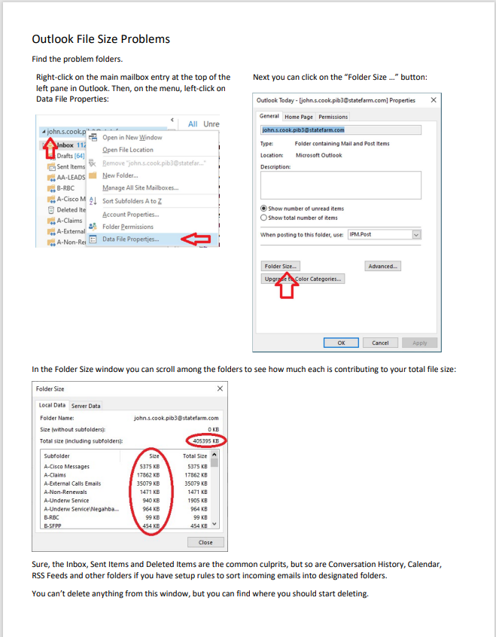

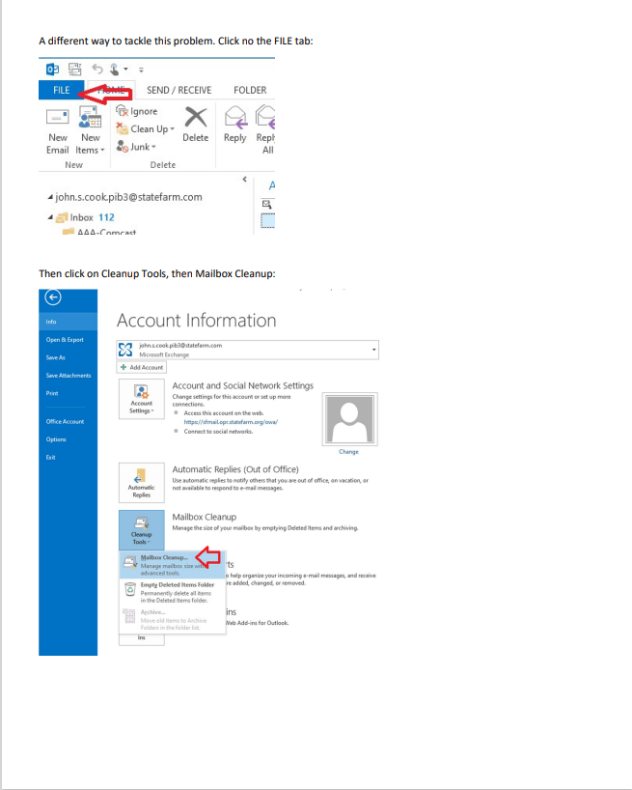

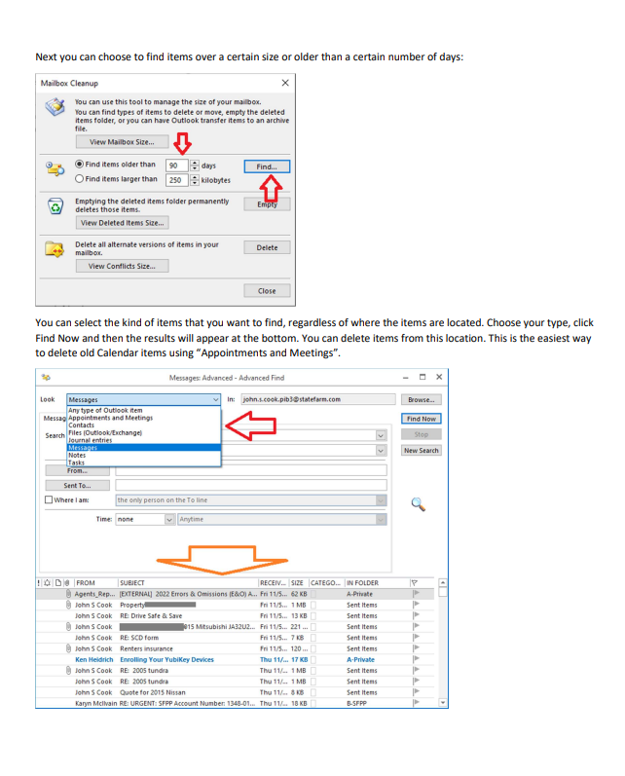

**NECHO Help:**

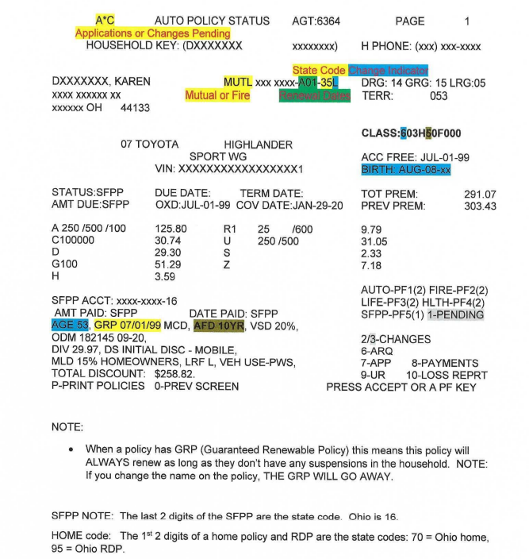

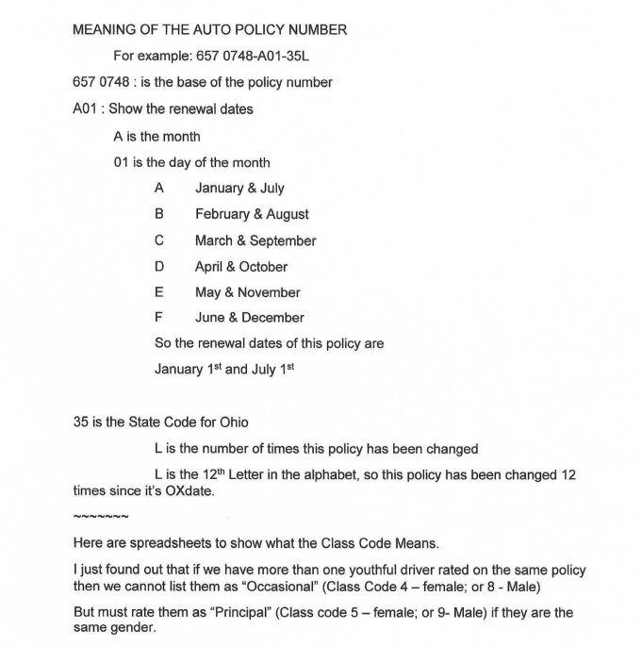

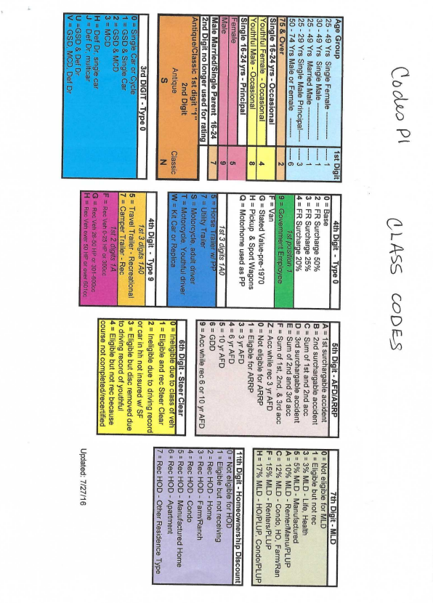

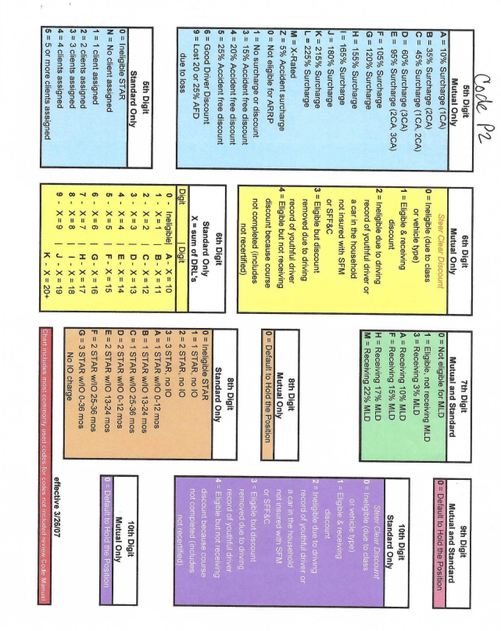

**Opportunities/Tasks/LOG**

**Home Page:**

* Goal: ZERO out your tasks every day!
* Any sales or service task that is assigned to you is your responsibility
* **"Open Opportunities w/o Open Tasks"**
  + YOU DO NOT WANT ANYTHING IN THIS REPORT
  + These are open opportunities that you are currently working on that do not have a task (follow up) associated with it
  + Make it a habit to check this either in the mornings or late afternoons

**Creating Opportunities**

* **Any opportunity is a chance for a future sale (whether that is tomorrow, next week, or in 5 years, it doesn’t matter)**
* Anytime you do not get a hard no from a customer after bringing up a certain product, you NEED to make an opportunity AND a task with it
* How to make an opportunity
  + Go to the person's account page
  + Click "New Opportunity" on top right corner & select State
  + Click the Line of Business (make multiple if you have multiple opportunities)
  + MUST put a marketing source
    - This is where you pick where the opportunity came from
  + Push save and quote (if you're ready right then and there to quote)
  + Push save if you're not ready to quote yet
* One the opportunity is made you need to update the stage to the appropriate stage
  + Create a task for yourself to follow up (this date will depend on the conversation, type of lead, etc.)

**Creating Tasks**

* Tasks are follow ups to opportunities
* These are what will circle back around to remind you to follow up with a customer
* There are different areas to create a task
  1. On an account page
     1. Only make a task on the account page if there are no other tasks to remind you to contact the customer
     2. It is not very often that you'll create a task on the account page
  2. Within an opportunity
     1. There must aways be a task
     2. If the opportunity is opened, there has to be some sort of task associated with it
     3. If the task is closed, there needs to be a task associated with it whether it's 3 months, 6 months, 1 year, or 5 years
  3. Within a case
     1. If there is an open case that still needs attention, create the task within the case
* ALL tasks will appear on the person's main account page no matter where they are created
* Create the task in the correct location, because if you create a task initially on the account page, you will not see it in an opportunity or case. They need to be created in the area they should be assigned to.

**Creating Logs**

* Logs are ways of noting important information about a customer that is beneficial to know by any person who pulls up the account page.
* Logs do not require follow ups, just simply important info that needs to be noted
* The "Log Title" should be vague, but not vague enough that a person can't tell what it was regarding without a single look
* Additional information regarding the log should be entered in the "comment" section"

**Premium Fund Account (PFA)**

**Overview**

The following Premium Fund Account (PFA) guidelines and requirements should be followed to ensure the funds are properly managed, accurate records are maintained, and internal controls are in place.

**Recommended PFA Deposit Practices**

Only Cash/Cash Equivalents and checks may be deposited into the PFA, this includes deposits made to cover monthly bank service charges.

Funds may only be removed from the PFA in the following ways: via EFT by State Farm® and by PFA check payable to State Farm with sufficient documentation to explain the reason why funds are being withdrawn from the account.

Every day premium money is received, a Final Deposit List should be completed with a corresponding bank deposit. Doing so helps ensure payment is updated to the policy in a timely manner. Variable Life agents are required to deposit Variable Life money the same day it is received.

The bank deposit total should **exactly** match the Final Deposit List total (except for transactions involving PFA checks, returned checks, incomplete payments, and deposits for monthly service charges which should be clearly documented in your register).

Final Deposit List payments showing as “Incomplete” represent unapplied customer funds. The money for the incomplete payment will stay in the PFA, and the policy/app will remain unpaid until the incomplete is completed and marked for telephone retrieval. Incomplete payments should always be completed within 15 business days.

Completing a Trial Deposit List does not initiate a transfer of funds to State Farm; a Final Deposit List **must** be completed. If a Trial Deposit List was completed in error, a Final Deposit List should be completed the second day. Because some of the funds have already been deposited at the bank, when prompted, add the total of the prior day deposit and cash on hand to reconcile to the Final Deposit List.

It is permissible to complete more than one Final Deposit List in a day, though no more than two are recommended. (Even if two Final Deposit Lists are completed in one day, the transfer for the day will usually appear as one transfer total on the bank statement.)

A corresponding bank deposit should be made the same day PFA checks are written. Making bank deposits the same date as the final deposit listing ensures funds are available and prevents overdraft charges and failed pulls. Once an ACH draft from PFA has been transmitted, there is no way to stop the ACH from pulling.

**Agent Review and Internal Controls**

The agent should review, sign, date and retain the worked copy of the printed History of Altered Money Report on a monthly (at a minimum) basis. The report is available at: ABS > Office Admin > PFA Bank Deposits > Tools > History of Altered Money. Transactions should be researched and clearly documented. The report helps detect potential inaccuracies associated with collecting Company funds and it can identify any training needs and/or potential integrity concerns regarding the handling of payments. Deleted cash payments represent the greatest risk. Agent team members are unable to access the report without leadership approval (via CCC Support).

PFAs should not be interest or reward bearing as the agent should not profit from premium deposits awaiting transfer to State Farm.

PFAs cannot have a line of credit/overdraft protection. (Both of these items could be considered commingling of funds.)

PFA monthly service fees and other maintenance charges are the agent’s responsibility. Periodic deposits should be made in advance to cover the bank fees. The resulting ongoing non-premium balance should not exceed $500.00.

The agent’s ongoing PFA balance of personal (non-premium) funds should **not** be continually negative.

**PFA Reconciliation**

* For manual/Excel records, the reconciliation should be performed by the agent or someone other than the person maintaining the register.
* The monthly bank reconciliation should be completed upon receipt of the bank statement, no later than 30 days after the bank statement ending/closing date. Timely and accurate completion will help identify issues (e.g., returned checks, incomplete payments, etc.) so that corrective action can be initiated as soon as possible.
* The agent should always print, sign and date the monthly bank reconciliation (even if completed by the agent). If someone other than the agent is reconciling the account, that person should also sign and date the reconciliation.
* Any uncleared transactions on the bank reconciliations must be researched and resolved so they should not continue to appear on the reconciliation. These transactions represent unresolved payments banking issues or inaccurate PFA transaction register entries.

**Taking Cash and Check Payments**

Do not cash checks or make change for large bills using funds collected for deposit to the PFA. This includes accepting third party checks not payable to State Farm. This reduces the agent’s exposure to loss from check fraud and counterfeit bills.

* If the bank confiscates counterfeit money when making a deposit, submit the PFA Reimbursement Form. (Left Nav > Forms & Service)

Petty cash should be kept separate from the premium money at all times. If a policyholder does not have exact change to make a cash premium payment, you may only make change from cash taken that day for other policyholder premium payments.

**Do not** enter transactions for $0.01 to bind a policy. A more significant portion of the premium must be collected to bind the policy. Agency leadership should be contacted for assistance with determining specific binding amounts.

If **Print Regional Copy for Mailing** is selected in error, the electronic transmission can be cancelled via PF6 to enter an additional payment (the original payment data is overwritten).

PFA checks and PFA deposit slips can be ordered via the PFA Re-Order form (Left Nav > Forms & Service).

A night drop box is **not** recommended. There have been several agents who used night deposit drop boxes and found that the bank lost their deposits. It is the agent’s responsibility to ensure the insured’s money is deposited into the PFA in person during standard banking hours.

**Note:**If a State Farm customer from a different book of business brings a cash payment to your office, see ABS > Services > Taking Payments > Business Leading Practices > Handling Payments for more information.

**Correcting Payments, Returned checks, and NSF Fees**

If a payment that appeared on a Final Deposit List needs to be corrected, an Agent Payment/Returned check Correction Request form must be completed (Left Nav > Premium Fund Account (PFA) > Forms & Service). Further questions can be directed to CCC Support. This form can be used for:

* Changing a payment amount
* Deleting a payment
* Placing a hold for a large dollar check or an annuity fund deposited into PFA
* Correcting a payment applied to the incorrect policy/account
* Correcting a returned check

The PFA Reimbursement Form (Left Nav > Forms & Service) can be used for:

* Reimbursing NSF charges caused by customer returned checks (requirements below)
* Reimbursing the PFA for counterfeit bills
* Reimbursing State Farm for excess returned check fees entered in ABS in error
* Authorized withdrawal of the agent’s personal funds

**Note:** Frequent and excessive use can result in a PFA review.

Your bank might offer a return check service to resubmit returned checks multiple times until the check clears. When returned checks are resubmitted multiple times this can cause several problems with both customer payments and the PFA. State Farm recommends contacting your bank to remove the return check service feature.

Additional information can be found on ABS > Services > Taking Payments > Payment Processing > Payment Corrections & Returned Checks.

**Reimbursement Requirements**

Overdraft fees may be reimbursed if they are caused by an insured’s returned check and if the following requirements are met:

* If a policyholder’s check returned Non-Sufficient Funds (NSF), it must be processed as a returned check in ABS within 30 days of the original payment date. This must appear on the Final Deposit List, **not** a Trial Deposit List.
* When the agent’s PFA does not reflect an ongoing negative balance
* If the request is submitted within 60 days of the occurrence
* If the agent is running a Final Deposit List each day premium transactions occur
* If the charge is not the result of agent and/or agent team member negligence

*Situations resolved with an Agent Payment/Returned Check Correction Request form are **not** eligible for reimbursement

Returned checks and returned check fees should be processed at ABS > Office Admin > PFA Bank Deposits > Tools > Returned Checks as soon as possible (the fees cannot exceed $40.00). Failure to do so in timely manner may cause the account balance to become negative.

A Final Deposit List should be completed if a returned check has been entered, even if no other premium payments were taken that day. **State Farm is unaware that a customer’s check has been returned until it is processed in ABS and appears on a Final Deposit List.**

For multi-payment returned checks, each policy should be entered separately, the same as it was originally entered as a payment on the Final Deposit List. State Farm cannot easily match payments to returns if the information differs and may result in a delayed or denied reimbursement to the PFA.

If funds fail to transfer to State Farm because a customer’s returned check has temporarily decreased the PFA balance, State Farm will automatically initiate a second attempt approximately one week later. This is the only acceptable scenario for a failed transfer (other than a bank error). If the one Final Deposit List total fails to transfer two or more times, ASR will contact the agent to schedule another attempt.

**PFA Review**

Financial Shared Services- Treasury Services completes periodic PFA Reviews which are administered according to adherence to the above guidelines.

**Support**

If you need NECHO or ABS technical support assistance, please complete the PFA Review Audit Questions Form (Left Nav > Forms & Service) to get a ticket to the PFA team.

Information tools and training are located at ABS > Office Admin > PFA Bank Deposits.

In the case of lost or stolen deposits, please contact:

* Your leadership about the situation with your lost or stolen PFA
* Contact the ASR at 1-877-889-2294 Option 3 to notify the ASR of the lost or stolen deposit.

In many cases, the PFA will become overdrawn due to the lack of funds. ASR is the area which works with the agent and the payment center to resubmit the withdrawal of the funds. ASR will need to be kept informed as the agent replaces funds so the ASR can initiate the deposit resubmit once all funds are replaced.

* For Possible reimbursement for overdraft fees associated with lost/stolen deposits, please complete the Premium Fund Account Reimbursement Form.

**Note:** Frequent and excessive use can result in a PFA review

**PFA Premium Fund Account Process**

Deposits are made at least every other day.

Box maintains a balance of:

$110.00 Cash

$10.00 Coins

NOTE: It is going to fluctuant a little bit as clients pay

How to run deposit:

* Go to ABS
* (Red Tab) Office Admin
* Trail/Final Deposit
* Print a copy of the trail deposit
* Balance the bag to the deposit
  + If a digit is wrong ask the team member who took the payment to go back and adjust.
  + If the team member is not there go in and adjust it but note it.
* After the bag is balance move to the box and balance it
* After everything is balanced as it should be fill in the appropriate boxes in the brown PFA folder, date, cash, checks, total, initials, and box balance.
* Enter the premium amounts in the boxes to finalize the deposit on the deposit screen.
  + Once you hit finalize it will ask you once more to make sure it is all balanced.
* Print a copy of the final deposit

A copy of the final deposit is hole punched and placed in the white PFA binder.

Dear [Plan sponsor name]:

It’s been [time period] since you selected me to serve as the financial professional for [name of company]’s retirement plan. I’ve enjoyed working with you and trust I’ve helped to improve your plan.

Over the past [X] months, I’ve conducted [X] group enrollment and education meetings. Also, I’ve spoken individually with [X] employees about the plan.

As of [date], [XX]% of your eligible employees are enrolled in the plan, with account balances averaging $[XX,XXX].

Since it’s a good idea for you, as the plan’s fiduciary, to conduct an annual plan review, I’d like to meet with you to discuss how things are going with your plan and set goals for making it even better.

I’ll give you a call in a few days to arrange a time for your plan review. Or if you’d like to speak sooner, I can be reached at [**xxx/xxx-xxxx**].

Sincerely,

[Your name]

**Investments are not FDIC-insured, nor are they deposits of or guaranteed by a bank or any other entity, so they may lose value.**

© 2014 American Funds Distributors, Inc.

**Call Script for outbound calls:**

Hi, _________?

This is __________ I received the form that you did online, but I need a few items of information to you confirm with…

* Is your date of birth ________?
* Your address is _________?
* How much are you currently paying?
* Who are you insured with now?

Alright, thank you for the information, let me transfer you to one of our specialists.

Objection: “I didn’t ask for a quote online or I wasn’t shopping”

Okay, I totally understand, and I do apologize if you’ve been bombarded with calls as for some reason your number came across our system as if you were looking for auto insurance…

So that I can make a note and stop the calls, can you tell me:

1. Who is your current provider?
2. How much are you paying now?

*\*\*If They Give You the Information Above\*\**

Since I have you in here anyway, are you okay if I email the quote over to (verify their email address) and to verify, what vehicles are you driving?

Alright, thank you for the information, let me transfer you to one of our specialists.

*\*\*If they don’t give you above, Send out 2 weeks\*\**

Objection: “I already went with someone else.”

Oh great! So, I can note my file, who did you end up going with?

Okay, awesome, how much are you paying?

I am going to go ahead and email you a quote over to verify if you are still driving _____. Perfect, since you already went with someone else, can I call you back in a couple month to see if we can earn your service?

*\*\*If they don’t give you above, send email to whom owns the opportunity to possibly close out*

**Schedule Appointments:**

Onboarding:

Hi ____. I am calling on behalf of State Farm for Adam Jurs. How are you doing today?

I am calling to schedule an in-person appointment with you in our office, we want to confirm that you are getting all the discounts you are eligible for and make sure your coverage reflects any recent changes or future plans.

The appointment may take 30 minutes to an hour. Does morning, afternoon, or evening appointments work for your schedule? He has some Saturday appointments available also.

Are you familiar with where our office is located?

Thank you _____. I appreciate your time and we look forward to seeing you on ______.

Investment Planning:

Hi ______. I am calling on behalf of State Farm for Adam Jurs. How are you doing today?

The reason for my call is to schedule an in-person or virtual appointment with you. We want to make sure you are aware we offer services to help you reach you financial goals.

The appointment may take 30 minutes to an hour. Does morning, afternoon, or evening appointments work for your schedule? He has some Saturday appointments available also.

I’ll send over a confirmation text the day before.

Are you familiar with where our office is located?

Thank you _____. I appreciate your time and we look forward to seeing you on ______.

**Referral:**

Hey ____, this is _____ over at Adam Jurs State Farm, in Greenfield. _____ shared your name with me to see if we can save you some money. We grow our business by helping our current customers friends and family. For every quote we give, we donate back to the Boys and Girls Club.

1. Who is your current provider?
2. How much are you paying now?
3. When was the last time you sat down with your agent?

Would you like us to run a FREE quote? Alright, thank you for the information, let me transfer you to one of our specialists.

(Team member) is currently busy; do you have a good time this week to set up a meeting?

Objection: “Can I call you back?”

Sure, what time works best for you? And while I have you on the phone, how much are you currently paying and are you still driving the _______. And one last question-your date of birth is ____ and your address is ________.

Objection: “Already with State Farm”

Alright, do you know what agent you are with? I want to document my notes, so we don’t bother you as we are all independent agents….

Objection: “Dad does my insurance”

Okay, that’s great. What is your dad’s name and number, so I can reach out to him in regarding this?

Scheduling for A Meeting (On Calendar):

We are wanting to review your account with you in office, what is a good time for you in the next week or so?

If Someone Asks for Adam:

I’m sorry, but he is in a life insurance meeting now.

* What is it that I can help you with?
* Okay, and whom am I speaking to?

Alright, I will get this to him, but the best way to get ahold of him is to email him, at jursinsurance@gmail.com

Marketing for Adam:

Adam can’t take calls during the day regarding advertising or marketing. The best thing I can do is give you an email to send information to and if he’s interested, he will email you back within 24 hours. That email is: [jursinsurance@gmail.com](mailto:jursinsurance@gmail.com)

If Someone Asks for another team member:

1. Try and find out what the person needs
2. If team member is on the phone
   1. (team member) is not available, what can I help you with”
3. If they insist to talk to a specific team member- let them know they will have to call them back
   1. See note on email to send for call back

“Yes, you called me in regard to a form being filled out online?”

Thank you for calling me back! Yes, you were trying to save some money on your auto insurance, and I just must verify a few things on my end to get you the best pricing. Are you still living at _________? Is _________ still your birthday? Are you still driving the ____________, and finally, how much are you paying per month right now? Great, let me get you over to (name), my pricing specialist, and she can finish things up for you!

*\*\*At The End of Every Call Verify the Customers Phone, Email and Address\*\**

**Leaving Voicemails:**

Voicemails From Call Lists:

1. Hey ______. This is ______. I have the information you requested. Please call me back at 317-452-6506. Thank you and have a great day!
2. Hey _____! I have a quick question for you, please give me a call back ASAP, at 317-462-6506. Thank you!
3. Hey _____. This is _______. I am unable to finish your request, give me a call ASAP. 317-462-6506. Thank you!
4. Hey _____. This is _____. I am missing some information on the forms you sent over. Please give me a call back as soon as you can, at 317-462-6506. Thank you!

**Sending Out Messages (Email or Text):**

Follow Ups

1. Hey _____! _______ asked me to reach out and follow up and reach out with you on your search for ________. Give us a call when you can! Thank you!
2. Hey _____! _______ has asked me to reach out and follow up on things on _____. Please give us a call at 317-462-6506. Thank you!

**Business Script:**

Hey there! This is ______ and we have sent you a few mailers recently. We are number one in small business, and it’s our Owner’s passion to help other small business owners. We just saved a local lawncare company over $15,000 a year, which allowed him to reinvest in his employees to keep them working for him longer. Adam would like to swing in and introduce himself. Is there a time that (owner) is available on Monday?

Objection: “No Thank you.”

That’s completely understandable, and may I ask, what do we have to lose? Best case, ______ meets a new friend and you save some money. Worst case, you had a professional point out what could be missing on your current insurance coverages. Can Adam swing in next week?

**Sending Out Emails for Adam:**

Investment Communications:

*______,*

*As your registered State Farm® agent, part of my role is to help you make sense of what’s going on in the financial markets and how that’s impacting your investments. With this in mind, I’m excited to share new daily, weekly and monthly publications from State Farm that are designed to educate and inform through easy-to-understand content.*

* [***Daily Market Monitor***](https://static1.st8fm.com/en_US/downloads/sf/daily-market-monitor.pdf)***–****Where we track the most relevant financial and economic news of the day.*
* [***Chart of the Week***](https://static1.st8fm.com/en_US/downloads/sf/chart-of-the-week.pdf)***–****Published each Monday, we explain key data points shaping today’s global market landscape.*
* [***Monthly Viewpoints***](https://static1.st8fm.com/en_US/downloads/sf/monthly-viewpoints.pdf)***–****Posted the first business day of each month, we dive into the most relevant market developments that are top of mind for investors.*

*Take a look through this material and let me know what you think. I’d appreciate your thoughts, as well as the opportunity to talk through questions you might have on today’s market environment and/or your investments with State Farm.*

*Also, you can always find the latest version of these new publications by navigating to statefarm.com® > Investments > Mutual Funds > (bottom of page)*[*News & Market Analysis*](https://www.statefarm.com/finances/mutual-funds/news-market-analysis)*.*

*Sincerely,*

*Adams Jurs*

Securities distributed by State Farm VP Management Corp. **Securities are not FDIC insured, are not bank guaranteed and are subject to investment risk, including possible loss of principal.** Neither State Farm nor its agents provide tax or legal advice.  
**AP2021/07/1119**

**New Agent Onboarding**

**TEAM MEMBER INSTALLATION GUIDE**

**Agent System FIRST…**

* Right Click on Agent Mailbox: **firstname.lastname.alias@statefarm.com** (right above Inbox)
* Folder Permissions > Add > type TM’s Names > Add > OK
* Click on TMs name and change Permission Level to Editor

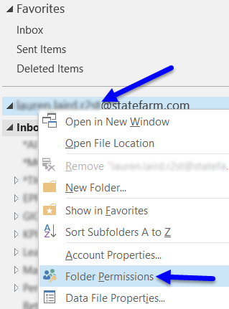 > 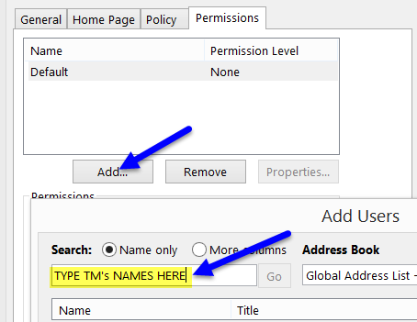 > 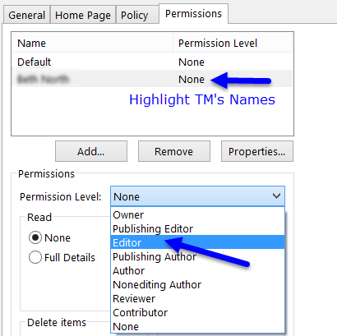

***Team Member Steps***

**STEP 1 – Setup OSO-Ez folders on all new Team Members computer systems**

**On the Team Member’s computer**

* *Right-click on* ***TM’s Mailbox (firstname.lastname.alias@statefarm.com) >*** Data File Properties
* Click on the **Advanced Button** at the lower right > **Advanced Tab** on top
* Under the section labeled Mailboxes, click “Add” then type the **Agent’s Alias or Name**
* Click OK on all remaining dialog boxes and the shared folders should appear on left side

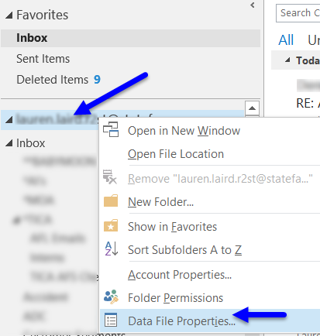 > 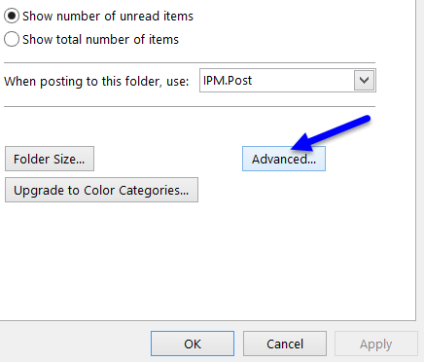 > 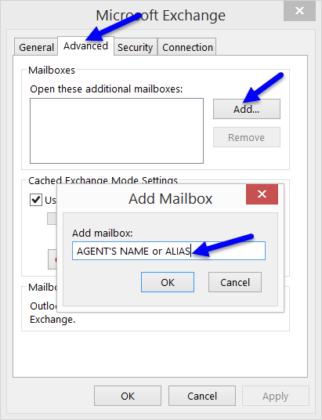

**Underwriting Folders:**

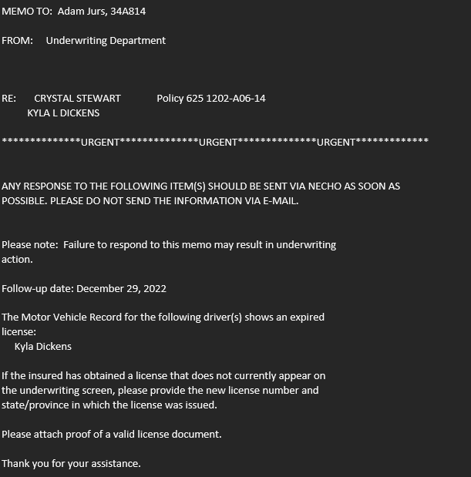

**Call the customer and get updated Driver’s License info- text if no answer. Once info received, put in Necho change with updated info**

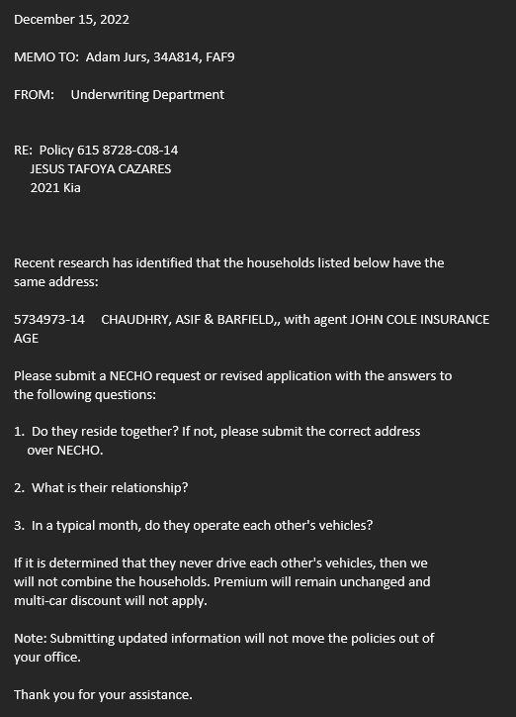

**Call the customer and get info for questions. Put in Necho change with info requested.**

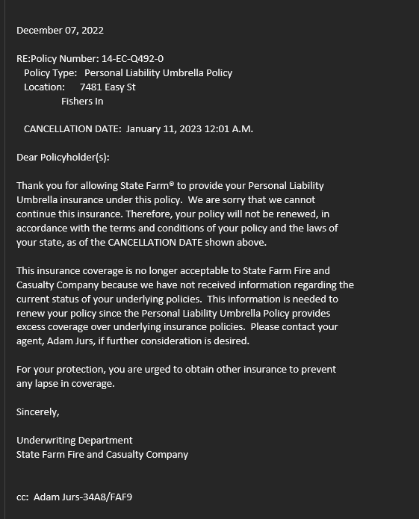

**Call Customer and let know info**

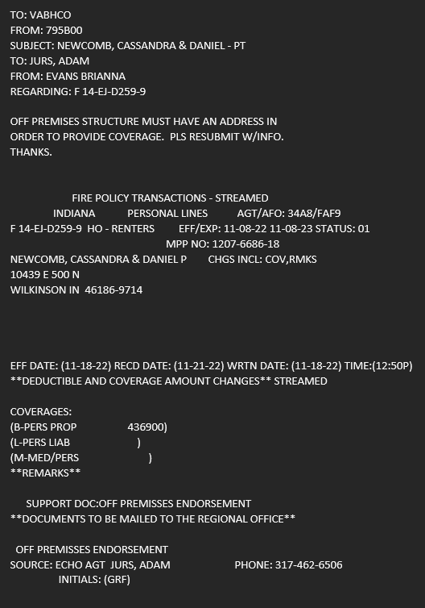

**Call customer to get address for off premises structure. Resubmit Necho change with info and supporting docs.**

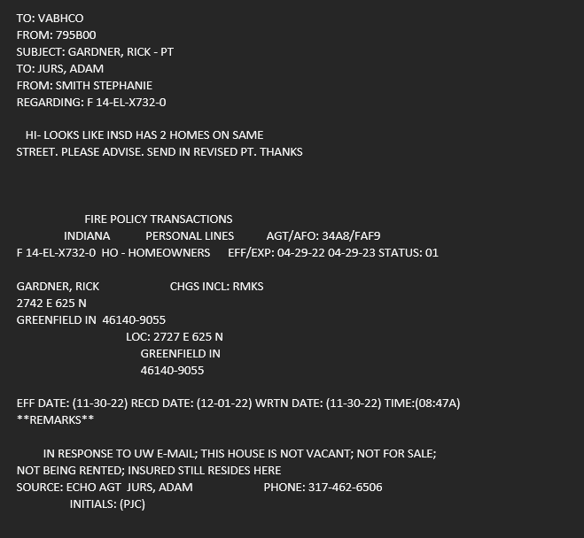

**Call insured to confirm if they have 2 homes. Put in Necho change with info.**

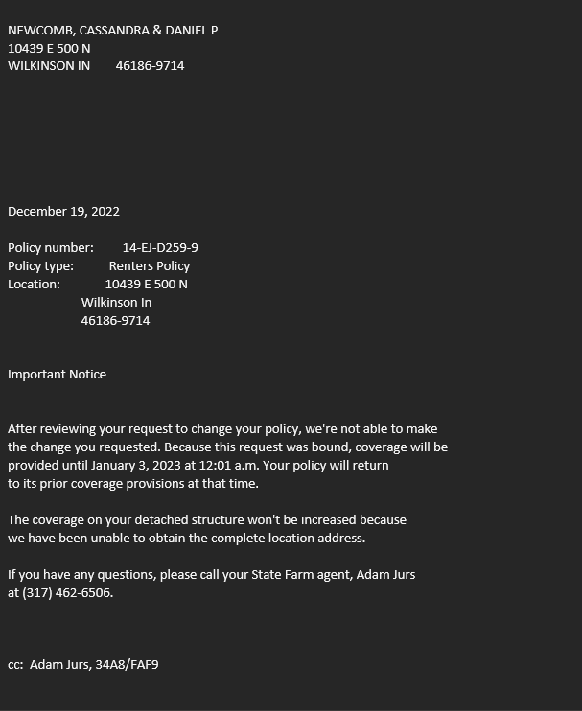

**Call the customer and let them know, try and get info that is needed again and submit Necho change if info received**

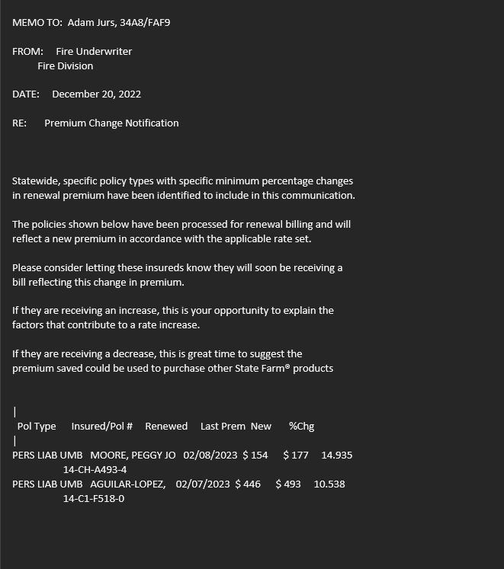

**Copy and paste info in customer’s ECRM as a note**

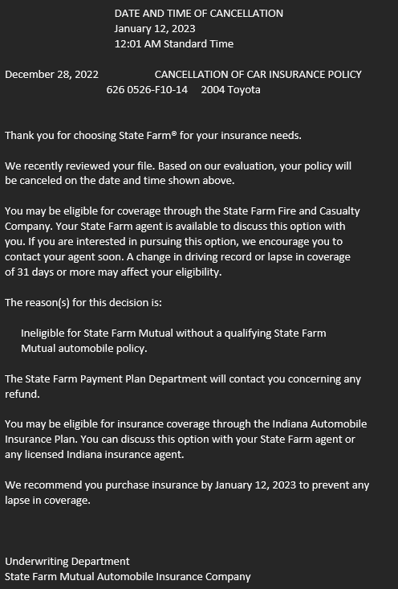

**Email person who wrote initial policy to rewrite in Standard. PLCC will be able to give you the Star level it should be written s.**

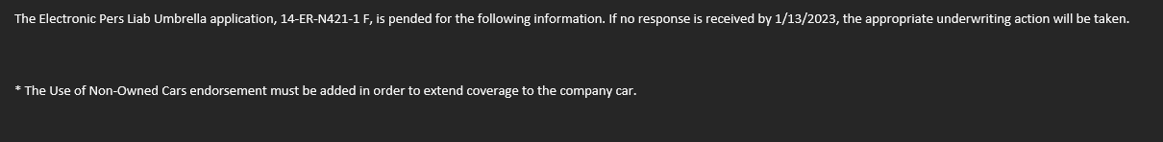

**Submit UAX form with the info requested on application- attach to original application in Production Manager**

**Changing the phones (Closing early, Opening late or closing on a Saturday)**

* Start in ABS on Office Admin tab.
* Then just underneath you will see a tab for “Phones & Computers”
* On the left side, about 3/4 down on page you will see: UC Self-Service App Access—click that link
* A new window will open with 6 icons—select MOBILITY
* A new screen will come up—near the top you will click on a box that says CCC Call Forwarding. A box will pop up with a REDIRECTION NOTICE, click on the box that says OK.

* A new window will open—2 columns. On the left side, make sure it shows the correct Agency Code.
* On the right side you will see the current schedule. There you can edit Open Time & Close Time. OR, if you don’t want phones to turn on at all, you just click the gray checkmark by that day. (Saturday of a Holiday weekend) Then, remember to change it back for the next week!
* For a “covered” holiday—you do not need to do anything.

**HOLIDAYS**

**Your lines will remain forwarded to the CCC on the following holidays.**

| **Holiday** | **Date** |
| --- | --- |
| New Year's Day 2023 | Sunday, January 1, 2023 |
| Memorial Day | Monday, May 29, 2023 |
| Independence Day | Tuesday, July 4, 2023 |
| Labor Day | Monday, September 4, 2023 |
| Thanksgiving Day | Thursday, November 23, 2023 |
| Christmas Day | Monday, December 25, 2023 |
| New Year's Day 2024 | Monday, January 1, 2024 |

This is the same screen where you can FORWARD/UNFORWARD phones in case of an emergency. You can Forward to CCC, Unforward or Forward to a different number (for example a Cell Phone) That is on the left side.

**Red Boxes setup at:**

Montana Mikes

Los Vaquesros

Lincoln Square

**Homeowners Policies-request for change of named insureds**

Anytime we receive one of these, loop Adam into the following:

* Current policy-who is listed
* What is the change being requested (ie. Somebody being added? Taken off?)
* When and who wrote the HO policy

Hello (Name),

We have been trying to reach you regarding your new policies. We are still waiting on the following:

* **Acknowledgment of Coverage Selection Rejection**
* **Steer Clear Form**
* **Grades/transcript for (Name)**
* **Photos of your vehicle**
* **Setup to be completed for Drive Safe & Save**

We want you to keep your discounts in place! We have emailed (insert forms attached) to (their email). Please complete and email back asap.

To setup your Drive Safe & Save, download the app and follow the steps to complete setup. Please let us know asap if you have not received your Bluetooth Beacon.

[](https://play.google.com/store/apps/details?id=com.statefarm.pocketagent&pli=1)       [](https://apps.apple.com/us/app/state-farm-pocket-agent/id318142137)

Please give us a call so we can go over your policies with you!

Thank you,

.

Filing SR22

Ohio:

Create Login:

[Registration - Identity Manager (ohio.gov)](https://services.dps.ohio.gov/IdentityManager/Login/CreateAccount/ac0794c4-937d-4240-b59b-74f58f19072a)

This is prompt you to verify your email and create your OWN login.

Please use work email.

You will need the insured:

Driver License Number

FULL Social Security Number

Indiana;

Create login

[BMV - Insurance Verification - Subscriber Sign](https://secure.in.gov/apps/bmv/olvs/subscriber.jsp)

Agent's Name - Your Name

Insurance Agency Name - Jurs Insurance and Financial Services

Business Address -

325 E Main St

Greenfield, IN 46140

Phone Number - 317-462-6506

Email Address - use your FULL State Farm email.

Agent License Number

License State - IN

The BMV will create a login user ID and password for you.

Filing an SR22 or COC

Insured Driver License Number

Drop down for Form Selection: SR22 - Proof of Future Financial Responsibility.

Once this is selected the system will select you to fill in the blank.

You will select

OPERATOR

Then State of Indiana

The owner is needed if the SR22 is required for the vehicle owner the insured WILL be notified from the state if this is needed.

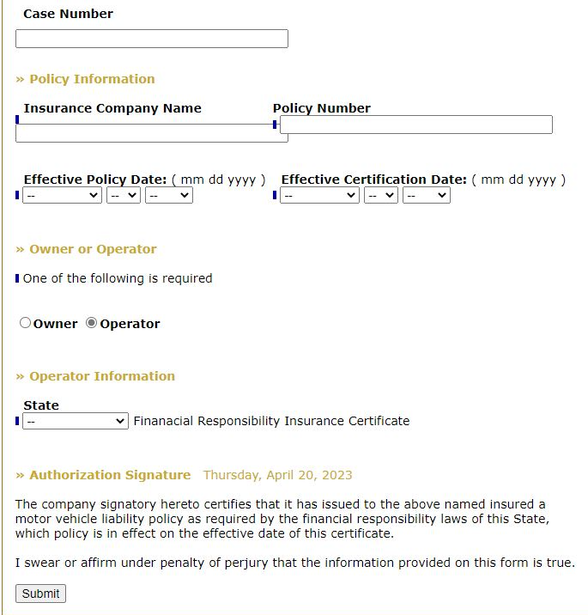

**Agency Values**

State Farm:

* Been in business over 100 years
* Number 1 in the industry and holding strong
* Offers a wide variety of products to protect your auto, home, and family

Agency:

* Open 6 days a week, late on Tuesdays and Thursdays, and 9-12 on Saturdays
* Office has a combined experience of over 35 years with State Farm
* 7 fully licensed agents in the office to help with all your needs
* We focus on education our customers and explaining their coverages, so they understand their policies
* Ranked in the top 15 in the nation of over 20,000 agents
* We service Indiana and Ohio

Agent:

* Grew up in a small town and loves getting to know people
* Passionate about helping people with financial planning and retirement
* Works with customers to ensure they are properly covered and understand their coverage
* Always growing and learning about new products and better ways to help our customers.

**Questions to ask for business insurance call ins:**

**Owner Name: __________________________________________________________________**

**Owner DOB: ___________________________________________________________________**

**Business Name: ________________________________________________________________**

**What Type of business is it: _______________________________________________________**

**How long have you been in business: ________________________________________________**

**Ownership years/roll: _________________________________________________________________**

**Are you an LLC, DBA, S Corporation, Sole Proprietor, C-Corp: ___________________________________**

**Address of business: _____________________________________________________________**

**Previous Business insurance: ______________________________________________________**

**Own or lease building: _____________________________________________________________**

**Any Employees: _________________________________________________________________**

**W2 or 1099:_______________________ Total Payroll Amount: __________________________**

**Workers Comp needed: __________________________________________________________**

**Gross Annual Sales: ______________________________________________________________**

**Business Autos: _________________________________________________________________**

|  |  |  |  |
| --- | --- | --- | --- |
| **Insured’s Name:** | | Primary Driver for added/replacement: | |
| ADDED or REPLACEMENT | | If Replacement: What are they getting rid of?  Same coverage as prior veh.? | |
| Year: | Make: | | Model: |
| Odometer: | | Annual Mileage: | |
| VIN: | | | |
| If NEW ask for MSRP: | | | |
| Loan or Lease? | | Bank Name: | |
| Add to monthly billing? | | Take first month’s premium. | |
| Best Phone Number: | | | |
| Other questions/comments: | | | |

|  |  |  |  |
| --- | --- | --- | --- |
| **Insured’s Name:** | | Primary Driver for added/replacement: | |
| ADDED or REPLACEMENT | | If Replacement: What are they getting rid of?  Same coverage as prior veh.? | |
| Year: | Make: | | Model: |
| Odometer: | | Annual Mileage: | |
| VIN: | | | |
| If NEW ask for MSRP: | | | |
| Loan or Lease? | | Bank Name: | |
| Add to monthly billing? | | Take first month’s premium. | |
| Best Phone Number: | | | |
| Other questions/comments: | | | |

**Life Amendments**

* When policy is approved and amended, person who sold policy communicates that a form needs to be signed.
* When the packet comes in with document that needs signature, service team will notify the person who sold the policy **allowing that team member to handle the task of letting the insured know we have it and what we need to have the follow up in our hands.** 
  + That person will contact the customer and communicate that document will be mailed out  **or scanned and emailed** and needs returned ASAP.
* Service team will mail it out as usual if not local to the area and note in ECRM.
  + Add a follow-up task 1 week after mailing out the paperwork for person who sold policy to reach out to customer and check on document.
  + Add a task in ECRM when the forms need returned by per UW notice.
    - This will be marked completed when form submitted through NECHO.
* When the paperwork comes back in the mail, notify the person who sold the policy.
* All contact with customer will be noted in ECRM and when document submitted in NECHO.

**FLOOD QUOTE PROCESS**

Log into Flood site: <https://nfipdirect.fema.gov>

* Once you enter a Username & Password NFIP will e-mail a “CODE” to be used to log-in.
* At the top of the page, you will click on **Quote/Application**
* You must Select Adam as Agent and then what address you want any Follow up e-mail to go to.
* Effective Date of Policy
  + If a new purchase it is effective on date of closing if there is a mortgage
  + If a new purchase it is effective on 30 days after application date if NO mortgage
  + If already owned and no prior policy—effective 30 days after application date
  + If replacing existing policy it can ONLY be done on renewal date
* You will need to determine the Flood ZONE—Community Number--Map Panel & Suffix
* This is obtained from a different website: <https://msc.fema.gov.portal/home>
* Enter the address and then Search
* You will get a page that looks like this.

* This has the info you need for the Flood ZONE—Community Number--Map Panel & Suffix
* In this case:
  + Zone-A (in the blue shaded area)
  + Community Number: 180084 (City of Greenfield)
  + Map Panel: 0124 (the last 4 digits of Green number –except the letter)
  + Suffix: D (the last digit of the green number
* You will need Mortgage info to write the policy but not required for a quote
* Just go through and answer the questions—It will tell you if you have missed anything.
* FOUNDATION—Super important!
  + If it is a Crawlspace that is more than 5 ft high—mark it as Basement
* NUMBER OF FLOORS—Crawlspace & Basement are considered “floors”
* If you have problems—Call them. They are very good about walking through the quote with you—especially if you have started it. 800-638-6620
* COVERAGE: Homeowner can choose
  + Building Only (most common)
  + Contents Only (very rare!)
  + Building & Contents
  + $250,000 is the MAX on Dwelling.
  + When the quote is calculated you will see this box

* Then you can click on Print Quote and it will show you other deductible options if they are available.
* At this point, You can call NFIP and ask them to verify accuracy of quote if you are unsure.
* This software automatically saves the quote which is super helpful.
* PDF of the quote can be emailed to the customer.

**COI**

Items needed before creating COI;

1 – Name and address of certificate holder.

2 – Is the certificate holder 1 time use or do they need to be listed as an additional insured (much like a mortgage company on a home) the certificate holder will tell the named insured if this is need and we MUST ask.

* If an AI is requested, the from must be filled out and attached to the change in NECHO to add. The CASE needs to list the ENTIRE COI certificate holder.

3 – Is a wavier of subrogation needed in place? The certificate holder will tell the named insured if this is need and we MUST ask.

Artisan Contractor/BOP

Open in ECRM - upper right corner of the policy there is a tab "Certificate of Insurance" and select it.

Put the correct date in.

You will need to have the certificate holder filled out WE DO NOT DO BLANK COIs.

* Select the type of recipient:
  + Additional insured
    - If they request to be listed as an additional insured there is another form we MUST submit as a change in the case -- BLRC - Additional Insured.
  + One-time Certificate Holder
* Fill in as it needs to read from the holder.
  + i.e. Hancock County 4H Fair Ground  
    123 Main St Ste 2   
    Greenfield, IN 46140

Options on the COI WILL show up even if the policy is NOT with our office.

Select the appropriate items. If the certificate holder is requesting a waiver of subrogation we must know and that is included in the request for the AI.

Description of Operation

* This is not needed unless requested by the certificate holder.

Create document and save it in the cloud drive labeled as COI -- (Certificate Holder Name) -- March Year

Make a LOG in the ECRM and it reads the same as the COI in the w driver.

Example saved in  W drive: COI - Hancock County 4H - April 2023

Example log in ECRM: COI Created - Hancock County 4 H - April 2023

How to add Additional Insure to the contractor’s policy:

* Business Tab in ABS
* You will select Business Lines Resource Center (BLCR) Red Hyperlink
* Check the state under BLRC Home Page (In or Oh)
  + IN the middle of the screen you will see the Business Fire Information
  + Hyperlink for Additional Insured.

Fill it out accordingly and always select BLANKET AI.

* + If you are filling out a AI request you 99% of the time will select the Waiver of Subrogation.
* Go back to the Account Card
* Select Policy Change
* In the Case notes make sure you add the AI details (name and address to match in NECHO)
* In Necho you will select option 18 and leave remarks that this is an AI request.
* In the change make sure to attach the AI request to the change.

**Credit/Checking Script**

Mrs. Johnson, I know that we just went over these increases and I also had a notification pop up that there is a way to save some additional money!!! There are two easy ways to get some cash back…:

1. The first is a new offer from US Bank and State Farm that allows you get $300 in cash back when you open a US Bank Smartly Checking Account and make more than one recurring payment linked to an SFPP Account
2. The second is the State Farm Premier Cash Rewards card, this card allows you to get
   * $150 cash back bonus by spending $500 in the first 90 days of being approved
   * Earn 3% cash back on insurance premium payments (up to $4,000 spent annually)
   * Earn 2% cash back at gas/charging stations, drugstores, grocery stores, and on dining.
   * Earn 1% cash back on all other eligible purchases.
   * Up to $600 in cell phone protection (when you pay monthly cell phone bill using card)

Which one of these would you be interested in and I can send you an exclusive invitation to apply. It only takes a few moments and we can put some money back in your pocket…..

**TEAM MEMBER INSTALLATION GUIDE**

**Agent System FIRST…**

* Right Click on Agent Mailbox: **firstname.lastname.alias@statefarm.com** (right above Inbox)
* Folder Permissions > Add > type TM’s Names > Add > OK
* Click on TMs name and change Permission Level to Editor

***Team Member Steps***

**STEP 1 – Setup OSO-Ez folders on all new Team Members computer systems**

**On the Team Member’s computer**

* *Right-click on* ***TM’s Mailbox (firstname.lastname.alias@statefarm.com) >*** Data File Properties
* Click on the **Advanced Button** at the lower right > **Advanced Tab** on top
* Under the section labeled Mailboxes, click “Add” then type the **Agent’s Alias or Name**
* Click OK on all remaining dialog boxes and the shared folders should appear on left side

